Test lab:

Address:

Reference: | Meeting of Vertical Group 7 13th of October 2008 (see the minutes)

Step 1. Calibration

The chain sharpness: -
has to be calibrated as usual according to item 7.5.3 of EN 381 part 1. It also should be controlled before each chain speed test (e.g. 16 m/s, 19 m/s; 20 m/s…).
Samples: calibration pads according to EN381-1:1993.
Test conditions: unwashed, 2 samples for chain speed 19 m/s, 2 samples for chain speed 21 m/s.
Set up: As calibration pads. With all needles along the attrapp. Guide bar 45 degree to the attrapp. Contact force 15 N in contact point.

Result:

Sample no: | Chain speed [m/s] | Free running stop time 4.0 s (yes/no) | Amount of protective layers cut (inlay) | Total amount of layers cut (= + outer + lining) | Cut through  Yes/no | Length of hole in lining  [mm]
1 | 19
2 | 19
3 | 21
4 | 21

Step 2. RR-Test of the cylinder 100 mm diameter
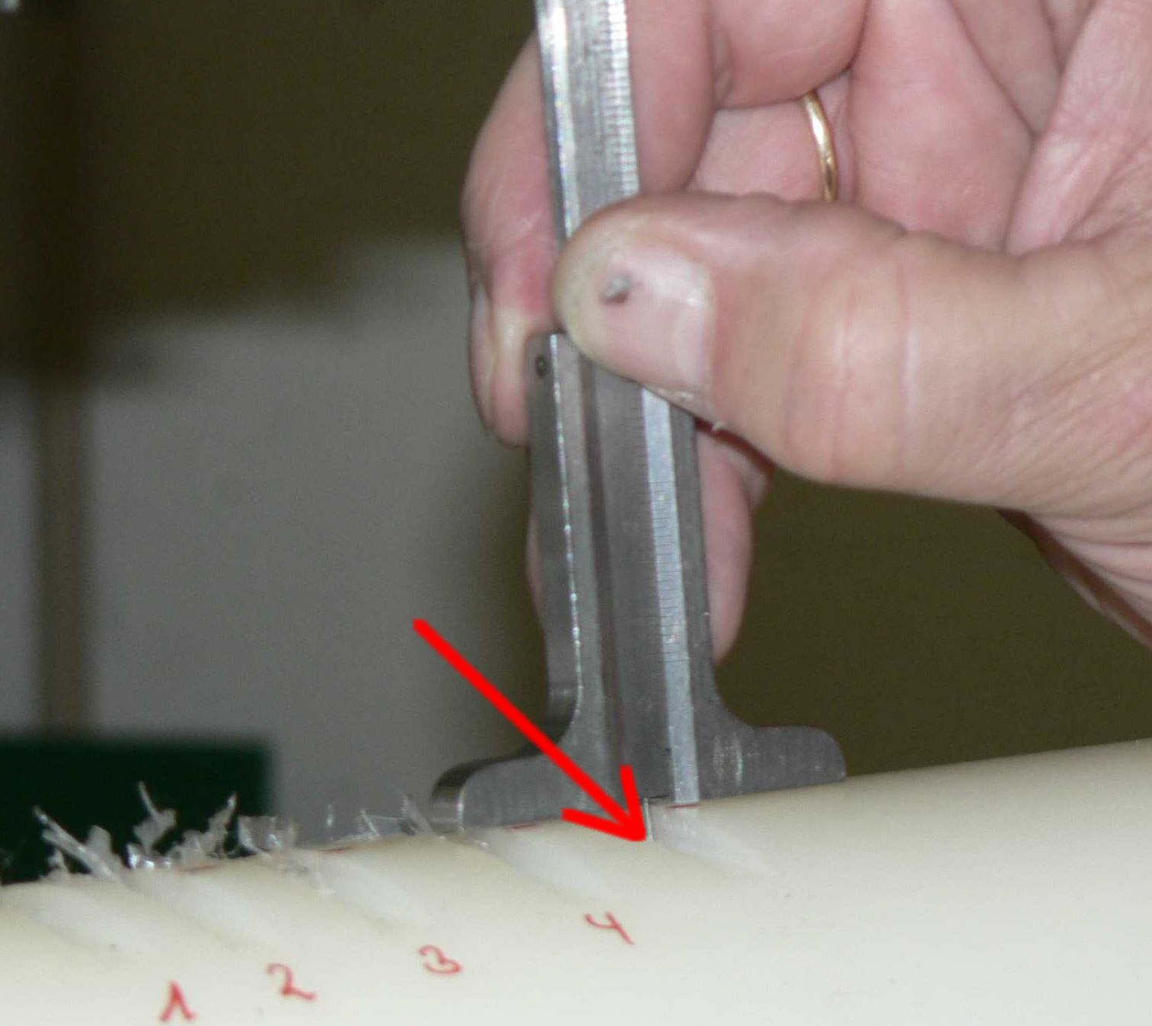
Please take the mesurements of the depth of each cut
at the left edge and circa in the middle of the cut !!
Make sure that there is no sawdust.

Carry out cuts into the PA 6 material.
The intention of the cuts is to measure the depth of the cuts carried out at different chain speeds (see minutes)
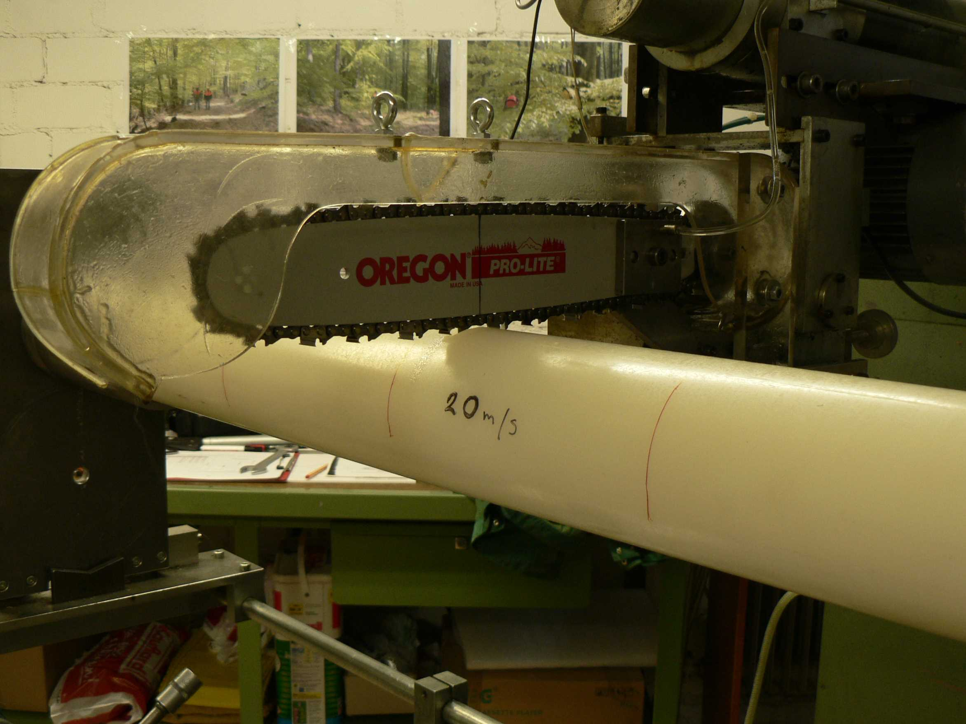
Cuts at 90° into the new PA 6 material

Results:

Chain speed [m/s] | Cut No. 1  (depth/ mm) | Cut No. 2  (depth/ mm) | Cut No. 3  (depth/ mm) | Cut No. 4  (depth/ mm) | Cut No. 5  (depth/ mm) | Cut No. 6  (depth/ mm) | Cut No. 7  (depth/ mm) | Cut No. 8  (depth/ mm) | Cut No. 9  (depth/ mm) | MEAN
16
19
20
21
24
25
28

Source and technical files of the material for the calibration of the chain sharpness, (according to EN 381 part 1 , Annex B)

Producer: Grünberg GmbH
Carl-Zeiss-Strasse 1
D-6332 Rödermark/ Ober-Rhoden
Tel. +49/(0) 6074-9 90 88
Fax + 49/(0) 6074-9 90 80
Internet: www.gruenberg-kunststoffe.de
E-Mail: gruenberg_kunststoffe@gmx.de
(gruenberg_kunststoffe@gmx.de)

Technical data:
material | PA 6 (Polyamid 6)
density | 1,14 g/cm³
absorption of humidity | 3,0 %
Thermal data
melting temperature | 220 °C (ISO 3146)
thermal conductifity | 0,23 W/(K.m) (DIN 52612)
coefficient of linear thermal expansion  mean between 20 °C and 60°C | 90x10⁻⁶ W/(K.m)
temperature of thermal dimensional stability | 75°C (EN ISO 75)
upper service temperature (short use/long term) | 160 °C / 85°C
lower service temperature ( | - 40°C
Mechanical properties at 23°C
breaking elongation | 80 MPa (ISO 527)
elongation at break | > 50 %
elasticity modulus | 3200 MPa (ISO 527)
Charty impact strength | >3 kj/m² (DIN 53453)
ball impression hardness | 170 N/mm² (ISO2039-1)
Shore(?) hardness | 82 Scale “D” (DIN 53505)
Electrical properties at 23°C
dielectric strength | 20 kV/mm (IEC 243)
specific contact resistance | 10¹⁵ Ohm.cm (DIN 60093)
specific surface resistance | 10¹³ Ohm (DIN 60093)
dielectric constant ξ at 50 Hz | 3,9 (IEC 250)
dielectric loss factor tan δ at 50 Hz | 0,02 (IEC 250)
creep resistance | CTI 600 (IEC 112)

