**Wellbeing of young migrant Men in the Czech Republic**

**Analysis of Existing Data Related to the Project Target Group**

Milada Horáková, Pavel Bareš

RILSA Prague, public research institution

May 2014

**CONTENT**

**1. Introduction** 2

**2. Migration into the Czech Republic** 3

**3. Available information on third country nationals-men 16-27 years according to relevant data and research** 5

***3.1 Foreigners´ Information System of the CR Ministry of the Interior*** 5

***3.2 Information system on TCN immigrants’ families*** 12

***3.3 Barriers to integration of young migrant men*** 16

***3.4 How do live migrants in Prague?*** 35

**4. Portrayal of foreigners in the Czech media – young foreigners and foreigners in general** 36

**5. Scholar reflection of challenges encountered by young foreigners** 39

**6. Synthesis of relevant findings on selected challenges** 40

**7. Migration and integration policy of the Czech Republic** 42

**8. Conclusions** 43

**References** 45

**Annex** 1

**1. Introduction**

The Czech Republic legislation does not recognise terms “immigrant” or “migrant”. It operates only with a term “foreigner” - a person who is not a CR citizen. For that reason the CR statistical data refer to foreigners only. Statistical data comprise citizens of the European Union (EU) or to be more precise citizens of the European Economic Area (EEA), and third countries nationals (TCN). For that reason we cannot refer to overall migrants’ situation[1].

Process of integrating immigrants into structures of the host society has the aim to achieve their equal footing into society. The integration process is multidimensional, having a specific focus and dynamics. Most frequently the integration process is analysed in terms of these dimensions: work, education, occupational preparation, health care, housing, participation in the social sphere (integration within the local community) as well as political participation. Integration policies usually focus on one of the indicated dimensions, only rarely taking into consideration multiple effects working simultaneously, in synergy, or conversely (INTERFACE, 2007, p.1).

Every individual integrates himself into specific social structures, which may differ in terms of social status and social prestige. Dynamics of the integration process is determined by clash of cultures of the native and immigrant population. As a result of their interaction gradual shifts occur in symbolic meanings, customs, habits, traditions, cultural norms and values. Consequently, international migration and subsequent integration of immigrants undergo continuous changes of some of the important codified values and standards incorporated in legal regulations (both domestic and international). International migrations are thus vehicles of a social change.

Social changes, occurring as a consequence of international migration, can result in social conflicts. Therefore an increasing attention is paid to immigrants’ integration into host societies. A natural pursuit of the native and immigrant population to maintain their own cultural identity generates certain tensions, which may lead to conflicts.

**2. Migration into the Czech Republic**

Since 1990 the Czech Republic (CR) has become an attractive destination for foreigners. The share of foreigners on population increased during the period 1993-2013 from 0.7 per cent up to 4.2 per cent. Number of foreigners holding residence permit increased during period 1993-2013 from 77.7 thousand to 441.5 thousand (by 363.8 thousand), i.e. 5.7 times.

Since the beginning of political and economic transformation of the CR the number of economic migrants has been increasing continually. At the beginning of the CR politic and economic transformation temporary migration prevailed significantly, later, number of permanently settled foreigners has continually increased. After accession of the CR into the EU an interest of foreigners to work in the CR started to grow again. The share of legally registered foreigners on the CR labour market increased from 1 per cent to 5.5 per cent[2] of labour force during the period 1993-2011.

Migrations of foreigners to the Czech Republic were caused above all by economic reasons for last two decades, but in the course of time family reasons became more important and temporary migration changed gradually into the permanent one. It was observable especially before the CR accession to the EU. The economic crisis after 2009 further strengthened settlement processes, although many foreigners lost their jobs. Majority of them did not return to home country and are waiting for improvement of economic situation of the CR. Strong foreigner’s interest in permanent settlement was caused by interest in stable residence status and access to labour and social facilities rights associated with above all permanent residency. Economic crisis slowed down influx of foreigners into the CR labour market, but total number of foreigners increased.

As of 31 December 2013 the total number of foreigners legally residing in the Czech Republic was 441.5 thousand, thereof 202.6 thousand resided temporarily (46 per cent)[3] and 238.9 thousand resided permanently (54 per cent) (FIS MI[4] 2014)[5]. As of 30 April 2014 the total number of foreigners legally residing in the CR increased to 446.1 thousand (+4.6 thousand) compared to December 2013; the number of permanent residents increased to 245 thousand (+6.2 thousand ) and the number of temporarily residing foreigners declined to 201 thousand (-1,6 thousand). Share of permanently residing foreigners and temporarily residing foreigners on total number of foreigners was 55 per cent or 45 per cent respectively.

*Figure 1 Development of number of residence permit in the Czech Republic during period 1993-2013*



Source: FIS MI. Note: the decline of number of residence permits in 2000 year was caused by the change of Act No.326/1999 Col. On the Residence of Aliens on the Territory of the Czech Republic.

*Figure 2 Development of long-term and permanent residence permits during period 1993-2013*



Source: FIS MI.

Total number of third countries nationals (TCN) as of December 31 of 2013 was 267 148. Share of TCN on total foreigners´ population legally residing in 2013 was 60.7 per cent; TCN men made 58.8 per cent of total men in sum total of foreigners. The female migrations were more frequent for TCN group than for EU group and increased continually since 1993. On the contrary, migration of men was significantly higher for EEA/EU citizens than for TCN ones (617 per cent versus 54 per cent) in 2013. The explanation is that the EU citizens – men are overrepresented between highly qualified foreign labour force and work as top managers and highly positioned professionals. Highest share of permanently settled is between Vietnamese nationals (76%), especially between women (77%) see table 2b.

Largest (TCN) groups according to FIS MI data from December 2013 were: Ukrainian citizen (105.2 thousand), Vietnamese citizens (57.4 thousand) and Russian Federation citizens (33.4 thousand). These three groups made 74 per cent of total registered TCN residents as of December 31 2013, 84 per cent of total permanent registered TCN and 67 per cent of temporary registered TCN; Interest in settlement showed largest groups of foreigners, i.e. Slovaks, Ukrainians, Vietnamese, and Russians.

The share of men in foreigners’ populations was 57 per cent in 2013; among temporary resident permit holders it was higher (61 per cent), than among permanently settled foreigners (53 per cent). It is because males’ migration is typical for temporary labour migration.

*Table 1 Foreigners according to registered type of residence as of 31 December 2013 by FIS MI*

|  |  |  |  |  |  |  |
| --- | --- | --- | --- | --- | --- | --- |
| Group of foreigners | Type of residence | Men | | Women | | Total |
| Abs. figure | Share in % | Abs. figure | Share in % |
| All- foreigners | Temporary | 123 813 | 61,10% | 78 819 | 38,90% | 202 632 |
| Permanent | 126 102 | 52,80% | 112 802 | 47,20% | 238 904 |
| Total | 249 915 | 56,60% | 191 621 | 43,40% | 441 536 |
| TCN | Temporary | 53 592 | 55,40% | 43 120 | 44,60% | 96 712 |
| Permanent | 90 782 | 53,30% | 79 654 | 46,70% | 170 436 |
| Sum total TCN | 144 374 | 54,00% | 122 774 | 46,00% | 267 148 |
| EU | Temporary | 70 221 | 66,30% | 35 699 | 33,70% | 105 920 |
| Permanent | 35 320 | 51,60% | 33 148 | 48,40% | 68 468 |
| Total | 105 541 | 60,50% | 68 847 | 39,50% | 174 388 |

Source FIS-MI, calculations M. Horáková RILSA

*Table 2a Largest TCN groups according to type of residence and gender as of 31 December*

|  |  |  |  |  |  |  |
| --- | --- | --- | --- | --- | --- | --- |
| Nationality | Type of residence | Men | | Women | | Total |
| Abs. figure | Share in % | Abs. figure | Share in % |
| Ukraine | Temporary | 21 864 | 59,8% | 14 727 | 40,2% | 36 591 |
| Permanent | 34 849 | 50,8% | 33 799 | 49,2% | 68 648 |
| Total | 56 713 | 53,9% | 48 526 | 46,1% | 105 239 |
| Vietnam | Temporary | 7 805 | 57,7% | 5 726 | 42,3% | 13 531 |
| Permanent | 24 535 | 55,9% | 19 340 | 44,1% | 43 875 |
| Total | 32 340 | 56,3% | 25 066 | 43,7% | 57 406 |
| Russian Federation | Temporary | 6 934 | 42,8% | 9 257 | 57,2% | 16 191 |
| Permanent | 7 790 | 45,2% | 9 434 | 54,8% | 17 224 |
| Total | 14 724 | 44,1% | 18 691 | 55,9% | 33 415 |

Source FIS-MI, calculations M. Horáková RILSA

*Table 2b Largest TCN groups according to type of residence and gender as of 31 December 2013*

|  |  |  |  |  |  |  |  |
| --- | --- | --- | --- | --- | --- | --- | --- |
| Nationality | Type of residence | Men | Share of residence type in % | Women | Share of residence type in % | Total | Share of residence type in % |
| Ukraine | Temporary | 21 864 | 38.55 | 14 727 | 30.35 | 36 591 | 34.77 |
| Permanent | 34 849 | 61.45 | 33 799 | 69,65 | 68 648 | 65.23 |
| Total | 56 713 | 100.00 | 48 526 | 100.00 | 105 239 | 100.00 |
| Vietnam | Temporary | 7 805 | 24.13 | 5 726 | 22.84 | 13 531 | 23.57 |
| Permanent | 24 535 | 75.87 | 19 340 | 77.16 | 43 875 | 76.43 |
| Total | 32 340 | 100.00 | 25 066 | 100.00 | 57 406 | 100.00 |
| Russian Federation | Temporary | 6 934 | 47.09 | 9 257 | 49,53 | 16 191 | 48.45 |
| Permanent | 7 790 | 52.91 | 9 434 | 50.47 | 17 224 | 51.55 |
| Total | 14 724 | 100.00 | 18 691 | 100.00 | 33 415 | 100.00 |

Source FIS-MI, calculations M. Horáková RILSA

**3. Available information on third country nationals-men 16-27 years according to relevant data and research**

Young migrants aged 16-27 years were not a subject of independent sociological survey so far. Information on them is derived from several research studies, from which the target group of young men could be selected.

***3.1 Foreigners´ Information System of the CR Ministry of the Interior***

Data for the target age group of the MiMen project (16-27 years) are not monitored in official statistics. Therefore FIS MI data collected in the project “Information system on TCN families” were utilized for the description of the target group. According to these data total 29.2 thousand TCN young men between 16-27 years, i.e. 18 per cent from total 159,437 TCN men were registered in the CR as of December 31 of 2011 (See Table 3).

The proportion of young men and women in TCN in the age group 16-27 years was as follows: 52 per cent men, 48 per cent women. The highest share of men from all TCN age groups was among men aged between 26 and 27 (in both cases 57 per cent). Lowest share of men (47 to 49 per cent) was observed among TCN aged 20–22 years. However, in total, observed differences in the share of men by age were relatively small. As regards the gender structure, two groups of young TCN should be distinguished: TCN aged 16-23 and TCN aged 24-27. Whereas in the first group the share of men and women is comparable, in the second group men prevail (See Table 3).

Total number of men in each one-year age group of TCN men was slightly growing with age. Each of three youngest observed categories (men aged 16, 17 and 18) represented less than 1 per cent of all TCN men (and around 5 per cent of the target group). Each of three oldest observed categories (men aged 25, 26 and 27) represented more than 2 per cent of the whole sample of TCN men (and more than 10 per cent from the target group respectively). The total number of TCN men in last four age categories (24-27) represented half of the whole sample of TCN men 16-27.

*Table 3 Target TCN age groups 16-27 years as of December 31 of 2011*

|  |  |  |  |  |
| --- | --- | --- | --- | --- |
| Age | TCN men total | Share of men in % | Share of 16-27 age group in total TCN men | Share in total TCN men |
| 16 | 1 127 | 52% | 4% | 0.7% |
| 17 | 1 242 | 52% | 4% | 0.8% |
| 18 | 1 416 | 51% | 5% | 0.9% |
| 19 | 1 815 | 50% | 6% | 1.1% |
| 20 | 1 875 | 49% | 6% | 1.2% |
| 21 | 2 061 | 47% | 7% | 1.3% |
| 22 | 2 211 | 48% | 8% | 1.4% |
| 23 | 2 646 | 50% | 9% | 1.7% |
| 24 | 3 227 | 53% | 11% | 2.0% |
| 25 | 3 590 | 54% | 12% | 2.3% |
| 26 | 3 926 | 57% | 13% | 2.5% |
| 27 | 4 083 | 57% | 14% | 2.6% |
| Total 16-27 | 29 219 | 52% | 100% | 18.3% |

Source FIS-MI, calculations P. Bareš, RILSA.

Almost one third of TCN (32 per cent) men aged 16-27 were Ukrainians, 27 per cent Vietnamese and 11 per cent Russians. Young TCN men with citizenship of other countries represented 30 per cent of the observed target group.

Except Vietnamese, the age structure of TCN men by state citizenship differed from the structure observed in the whole sample (see figure 3). The men aged 26 or 27 were more often present among Ukrainians (36 per cent in comparison to 27 per cent in the whole sample). The share of men aged 18 or 19 years was highest among Russians (18 per cent in comparison to 11 per cent). The share of men aged 20-22 was highest both among Russians and people with other state citizenships (in both cases 28 per cent in comparison with 21). There is no single explanation for these differences, however specific factors for each group should be considered: stress on work migration in the case of Ukrainians or strategy to avoid army recruitment duty among young Russians. In the case of other countries the reasons of higher proportion of men aged 20-22 are even more individual.

*Figure 3 Target TCN age group 16-27 years (December 31 of 2011) by citizenship and age*

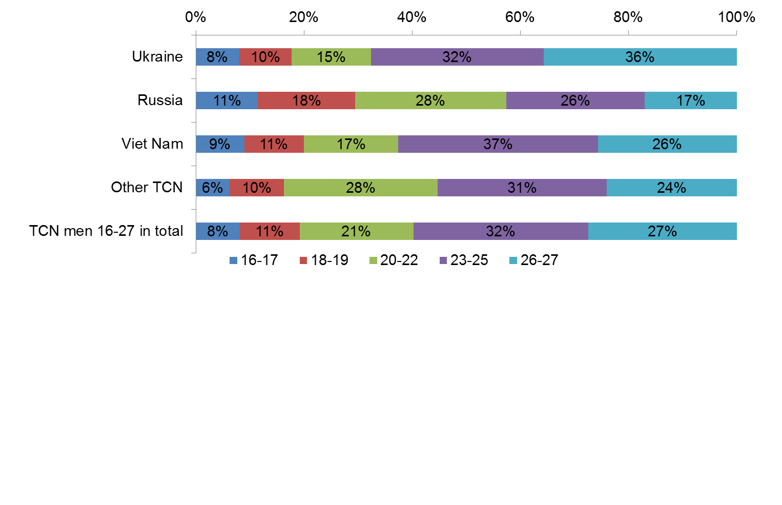

Source FIS-MI, calculations P. Bareš, RILSA.

Slight majority of young TCN men (54 per cent) had long-term residence status, about one third (35 per cent) had permanent status and eleven per cent had visa over 90 days. In the observed target group were TCN men with long-term residence mostly 23-27 years old (39 per cent in category 23-25 and the same percentage in category 26-27), while the number of men with permanent residence was comparable in all five age categories (the highest number of TCN with permanent residence was in age groups 20-22 and 23-25 years, however the reason was three-year interval in these two groups).

*Figure 4 Target TCN age group 16-27 years (December 31 of 2011) by residence status and age*

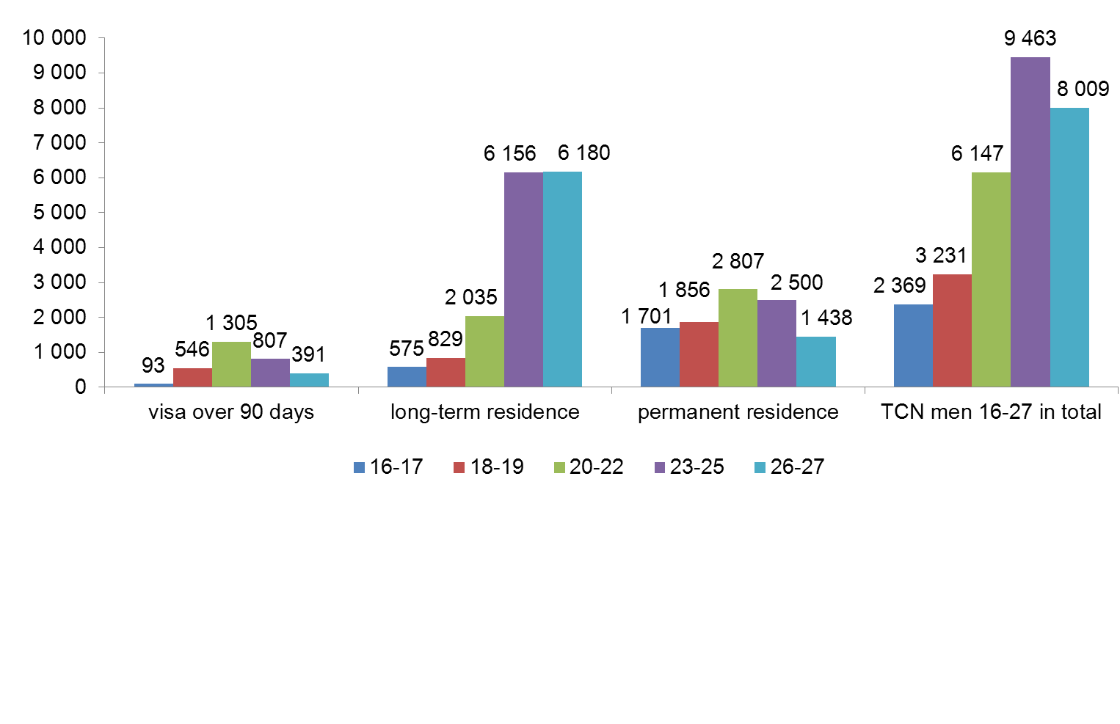

Source FIS-MI, calculations P. Bareš, RILSA.

The share of TCN with long-term residence status was highest among Ukrainians (66 per cent in comparison to 54 in the whole sample), the permanent status among Vietnamese (50 per cent in comparison to 35). Visa over 90 days were more frequent among Russians (17 per cent) and TCN citizens of other states (26 per cent).

TCN men in age 16-27 lived mostly in Prague (43 per cent), Central Bohemia (11 per cent), South Moravia (8 per cent), Pilsen region (8 per cent) and Ústí nad Labem region (7 per cent). The number of TCN men in age 16-27 in remaining 9 regions made up quarter of their population in the Czech Republic.

*Figure 5 Target TCN age group 16-27 years (December 31 of 2011) by region*

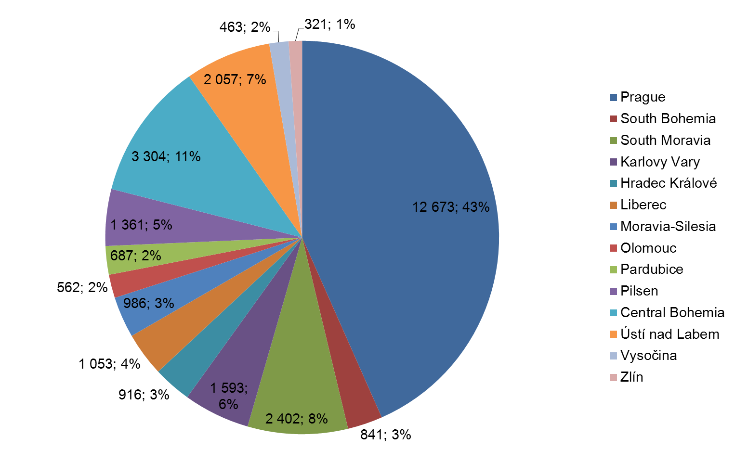

Source FIS-MI, calculations P. Bareš, RILSA.

The age structure of the target group was in majority of regions comparable. The highest share of TCN men under 22 years (50 per cent in comparison with 40 per cent in the whole sample) was in Karlovy Vary (Carlsbad) region, the lowest (27 per cent) in Pardubice region.

*Figure 6 Target TCN age group 16-27 years (December 31 of 2011) by region and age*

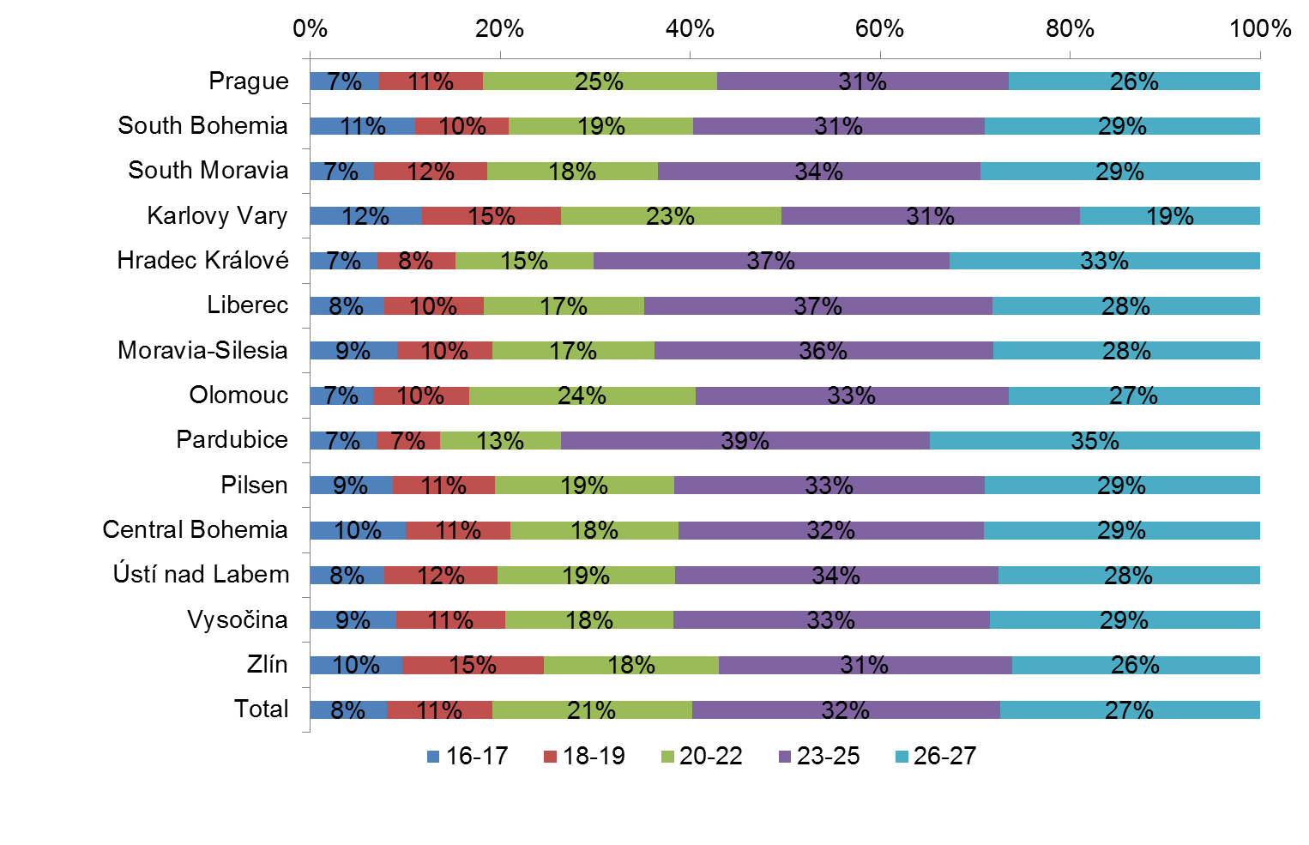

Source FIS-MI, calculations P. Bareš, RILSA.

According to state citizenship of young TCN men, the regions differed considerably. The highest share of Ukrainians was in Pardubice, Hradec Králové and Central Bohemia region (more than 40 per cent in these regions in comparison with 32 per cent in the whole sample). The share of Vietnamese was highest in Karlovy Vary (67 per cent in comparison with 27 in the whole sample), Moravia-Silesia (58 per cent), Ústí nad Labem (52 per cent) and Central Bohemia region (51 per cent). The share of Russians was highest in Prague (17 per cent in comparison with 11 per cent in the whole sample), Karlovy Vary (12 per cent) and Central Bohemia region (11 per cent). The share of Russians from 5 to 7 percent was observed in six regions and in remaining five regions they counted two or three per cent of total TCN men in the 16-27 group.

*Figure 7 Target TCN age group 16-27 years (December 31 of 2011) by region and citizenship*

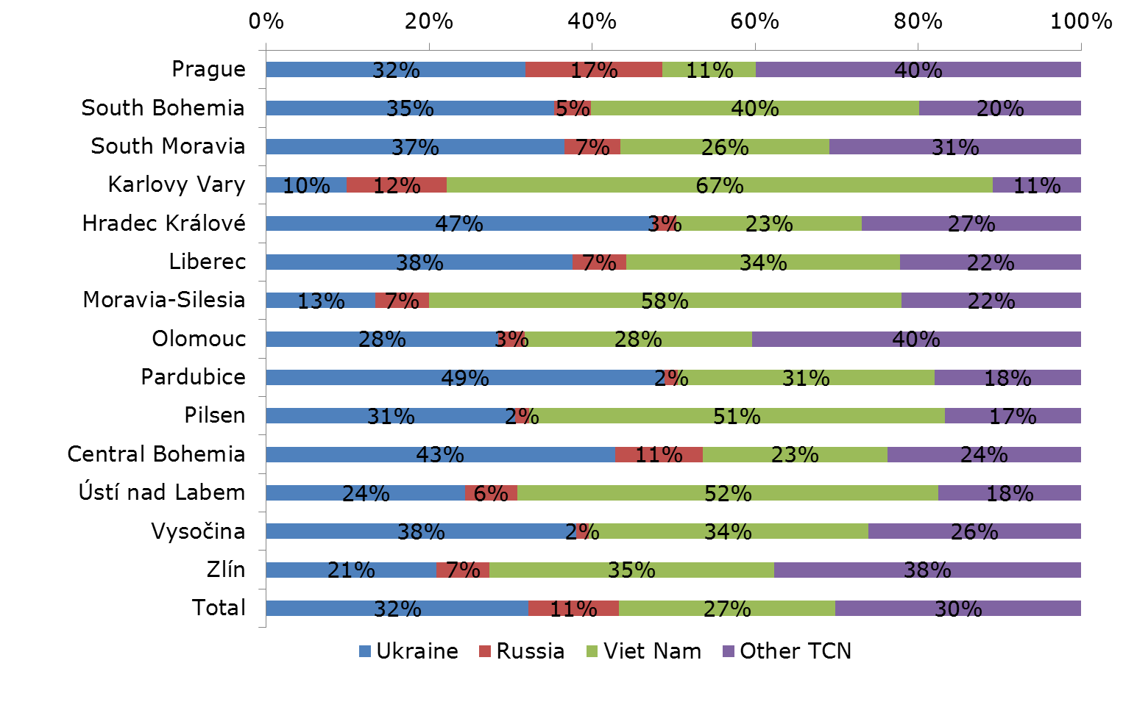

Source FIS-MI, calculations P. Bareš, RILSA.

The vast majority of TCN men 16-27 (93 per cent) were unmarried. Relatively small proportion of married men was observed even among men aged 23-25 (7 per cent), and men aged 26-27 (16 per cent). Among younger TCN men were married men only exceptional (one per cent or less).

*Figure 8 Target TCN age group 16-27 years (December 31 of 2011) by age and family status*

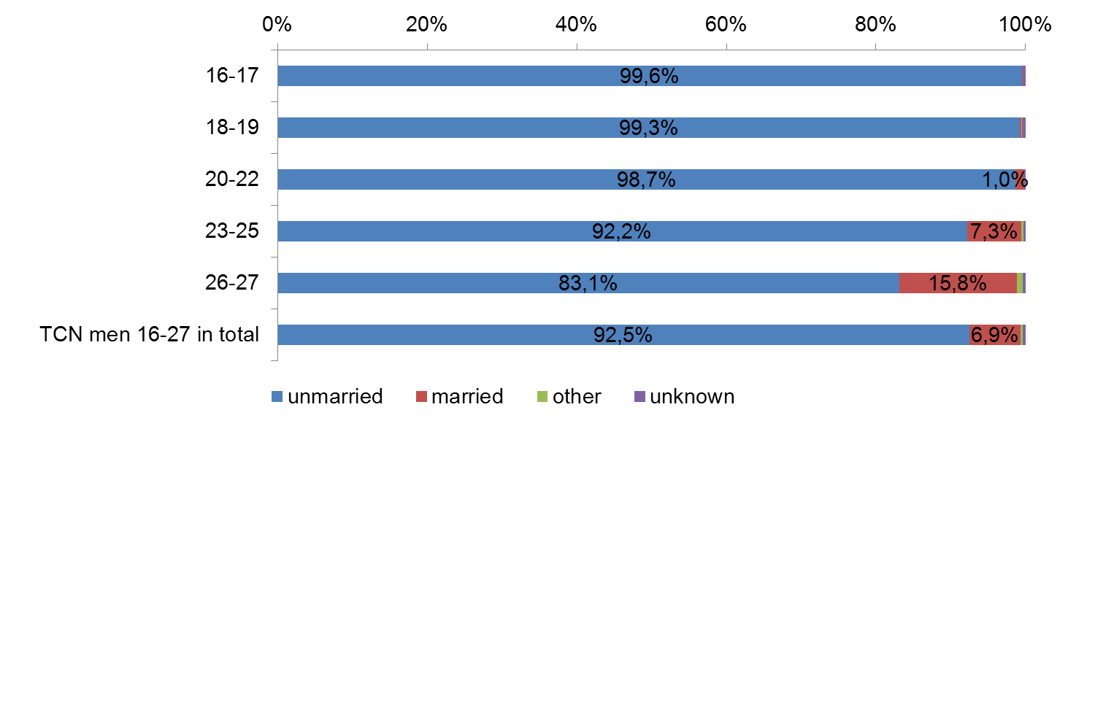

Source FIS-MI, calculations P. Bareš, RILSA.

Family or other similar[6] relation (hereinafter „family relation“ only) was determined for 12 613 TCN men in the age group 16-27 years (43 % of their total). Share of TCN with family relation was for group of men in particular age groups slightly lower than for all TCN (here this share was 49% - for more details (see Table 4).

Nature of the recorded family ties was further possible to observe only in general terms using average number of family relations per person with recorded family relation. Three fundamental types of recorded family relations were partner relation, parental relation, foster parent relation, and sibling relation. Using data from FIS MI it is also possible to follow some other types of relations (for example to other relatives, registered partnership, etc.); occurrence of these types of ties is however very small, therefore it is not included in the performed comparison.

For TCN men in the age group 16-27 years with a recorded family relation the average number of family relations per person was 1.87, i.e. by 0.24 more than average number of family relations for TCN men total. Thus for ten TCN men in the 16-27 years age group about 19 such relations were recorded, whereas for ten TCN men in total sample it was ca 16 family relations. The ascertained difference thus cannot be perceived as substantial and with regard to family relations group of TCN men aged 16-27 years differs from the entire TCN men sample only little.

But whereas only little differences were ascertained for all family relations, more detailed look at individual types of family relations being compared shows that both TCN groups differed markedly with respect to average number per person of family relations with partners and parents living in the CR. For men aged 16-27 years with a family tie the average number of partner relations was 0.12 (so about every tenth man in this age with family ties in the CR had partner relation), for all TCN men it was 0.65 (partner relation was recorded for more than six persons of ten TCN with family ties). The average number of parental relations was for men from 16-27 years group 1.47 (that is for ten persons with family ties ca 15 relations were recorded vis-à-vis parent living in the CR), for all TCN men this ratio was 0.81 (i.e. parental relation was discovered for eight of ten persons). The difference between the two TCN groups was recognizable also with regard to sibling relations. For men from 16-27 years group 0.26 these relations per person were discovered, for all TCN men 0.17. Whereas for ten men with a family tie aged 16-27 years there were ca three sibling relations, for all TCN with a family tie there were approximately two sibling relations.

*Table 4 TCN men aged 16-27 with family relations recorded in FIS MI*

|  |  |  |  |  |
| --- | --- | --- | --- | --- |
|  | | | TCN men 16-27 | All TCN men |
| Number of TCN | total | | 29 219 | 284 408 |
| with recorded family relations | absolute figure | 12 613 | 138 496 |
| percentage of total | 43% | 49% |
| Average number of recorded family relations* | total | | 1.87 | 1.63 |
| relations to | husband, wife or partner | 0.12 | 0.65 |
| parent, foster parent, etc. | 1.47 | 0.81 |
| sibling | 0.26 | 0.17 |

* Average number for one TCN man aged 16-27 with family relations recorded in FIS MI

The above findings can be summed up as follows: proportion of TCN who had other family members in the CR is for the group of men aged 16-27 lower (but not markedly) compared to all TCN. This is probably connected with higher willingness of younger persons to move to country, in which they have no relatives (or at least such persons cannot be reported as family members by existing statistics on TCN). Important role play also other TCN characteristics relevant for this age: compared to all TCN the ratio of married persons is minimal, they also only rarely have a family of their own, they cannot see a reason why another family member should move into the CR, or they do not have sufficient means, information or knowledge for that, etc.

For those representatives of the target group, who already have family members in the CR, is however typical slightly higher number of all family relations, compared to all TCN with family members living in the CR. At the same time men aged 16-27 years with relatives in the CR represent beyond any doubt primarily second or next TCN generation as their parents live in the CR markedly more often than for all TCN with relatives in the CR. They have more often in the CR also their siblings.

On the contrary the men aged 16-27 years have among family members living in the CR less often wives or partners. The main reason probably is only a small proportion of those who started their own family (as regard the family status, young men are predominantly unmarried – see above). This is not the only suitable explanation as some men around 25 year already started their family (this indicate further comparison of TCN men with family relations by age category). Very important is also fact that relationship to wife or partner is in FIS MI recorded only if the couple lives in the CR. If lower proportion of TCN men with their own family is one important cause of less frequent relation to wife or partner, separated families of those who started family in their country of origin (i.e. wife or partner could not or did not want to arrive in the CR) is another[7]

Nearly all men aged 16-17 had other family members in the CR. For following age categories the decrease in the share of TCN with family relations was remarkable: for men aged 18-19 to 7 out of ten in the respective age category, for men aged 20-22 to one half, and for men from 23 to 27 years to less than three out of ten persons.

Also average ratio of all recorded family relations per one TCN with family relations in the CR decreased with age, in all age categories it was however higher than the average determined for all TCN (1.63). Changes of average proportion of all family relations by age were less pronounced compared to previous indicator. Decreasing average number of all family relations with age was a result of decreasing ratio of parental relations with age. Ratio of sibling relations was not changing markedly.

*Table 5 TCN men aged 16-27 with family relations recorded in FIS MI*

|  |  |  |  |  |  |
| --- | --- | --- | --- | --- | --- |
| Age | % of TCN men 16-27 with recorded family relation in each category | Average number of recorded family relations* | Relations to | | |
| husband or wife, partner | parent, foster parent, etc. | sibling |
| 16-17 | 94% | 2.05 | 0.00 | 1.74 | 0.27 |
| 18-19 | 71% | 1.99 | 0.00 | 1.69 | 0.29 |
| 20-22 | 52% | 1.87 | 0.02 | 1.60 | 0.24 |
| 23-25 | 29% | 1.76 | 0.20 | 1.29 | 0.24 |
| 26-27 | 27% | 1.72 | 0.44 | 0.99 | 0.27 |
| Total | 43% | 1.87 | 0.12 | 1.47 | 0.26 |

* Average number for one TCN man aged 16-27 with family relations recorded in FIS MI

***3.2 Information system on TCN immigrants’ families***

The project “Information system on TCN immigrants’ families”[8] was carried out in 2012 by RILSA and IEAS[9] and collected data on total 61 TCN families, which included total 242 families’ members[10]. Mostly they lived within nuclear families in the CR (204 persons). By means of individual data sheet we collected data on 200 individual members of investigated families. From total sample of 200 respondents (both men and women) 15-17 years respondents constituted 5%, 18-26 years respondents made 15. 5%. Majority respondents were in age group 27 - 64 years.

*Table 6 Most numerous groups of TCN and their representation within sample of families*

|  |  |  |  |  |
| --- | --- | --- | --- | --- |
| Citizenship | Total TCN | Rank | Optimum for the sample of 61 families | Real number of families within sample |
| Ukraine | 118 923 | 1 | 25.6 | 25 |
| Vietnam | 58 205 | 2 | 12.6 | 13 |
| Russia | 32376 | 3 | 7.0 | 8 |
| Moldavia | 7 588 | 4 | 1.6 | 1 |
| Chine | 5 579 | 5 | 1.2 | 1 |
| Mongolia | 5 385 | 6 | 1.2 | 1 |
| Kazakhstan | 4 534 | 7 | 1.0 | 1 |
| Belarus | 4 199 | 8 | 0.9 | 1 |
| Bosnia and Herzegovina | 2193 | 9 | 0.5 | 1 |
| Armenia | 2035 | 10 | 0.4 | 1 |
| Total selected TCN groups | 241 017 |  | 52.0 | 53 |
| Other citizenship and mixed families | 41 860 |  | 9,0 | 8 |
| TCN total | 282 877 |  | 61 | 61 |

Source: Information system on TCN immigrants’ families (Horáková, Bareš, Schebelle, Kubát, Uherek et al. 2014. p. 144).

From total sample of 200 persons we selected group of young men between 17-24 years (total 18 respondents) and we described selected group for the purpose of our young migrant men Well-being research. One or more men between 16-27 years lived in 17 families (28%); therefrom in 16 families lived just one man aged 16-27 years, in one family lived 2 young men 16-27 years old.

*Table 7 Sample of selected young immigrants-men by citizenship and nationality 16-27*

|  |  |  |
| --- | --- | --- |
| Country | Citizenship frequency | Nationality frequency |
| Afghanistan | 1 | 1 |
| Armenia | 2 | 1 |
| Belarus | 1 | 1 |
| China | 1 | 1 |
| Croatia | 1 | 1 |
| Mongolia | 1 | 1 |
| Russian Federation | 1 | 1 |
| Viet-Nam | 4 | 4 |
| Ukraine | 6 | 7 |
| Total | 18 | 18 |

Source: Men aged 16-27 interviewed in the project Information system on TCN immigrants’ families (Horáková, Bareš, Schebelle, Kubát, Uherek et al. 2014), further only “Information system on TCN immigrants’ families / data on men aged 16-27”)

Altogether fourteen respondents resided in the CR permanently and two respondents resided temporarily; ten respondents came to the CR due to family reunion, five respondents for study, one for other purpose. Ten respondents lived in the CR for 12 years, five respondents for 22 years, one respondent over 22 years, one respondent between 1-2 years. Young migrant men in our sample were mostly single, only one respondent was married. All respondents lived in the CR with their nuclear family and one respondent lived together with his girlfriend.

Usually all family members came from one country of origin; only one family originated from more post-Soviet countries. Seven respondents were born in Ukraine, four in Vietnam, two in Armenia, one in Afghanistan, one in China, one in Croatia, one in Mongolia and one in Russian Federation. Before departure to the CR, five respondents lived in Ukraine, four in Viet-Nam and two in Armenia; one respondent lived in Afghanistan, one in Armenia, one in Bosnia and Herzegovina, one in China, one in Mongolia, and one in Russian Federation. All members of interviewed families had the same state citizenship except for one case, when family members had several post-Soviet citizenships. In 8 families main language for family communication was Czech, in five families it was Russian, in four families Vietnamese, in three families Ukrainian, in one family: Persian, Mongolian, Croatian, Chinese, Armenian language.

Eleven respondents lived in a complete family, three respondents in an incomplete family; two in two-generation family and one was another case. Status of selected respondents within family was in seventeen cases sons and in one case it was a distant relative of interviewed family.

Ten respondents finished secondary education with graduation, one finished secondary education with professional training without graduation and one finished university education; two respondents were professionally trained, thereof two respondents in machine industry, one in agriculture as a technician. Students studied following sectors: four respondents studied universal education programmes, two respondents studied music or theatre art, two respondents studied architecture or planning, one respondent studied technical sciences and one respondent studied law.

Total six respondents (from selected eighteen in the 17-24 years group) were employed; thereof five respondents worked as employees and one as a family helper. Employers of our respondents demanded from them in respective work places: in three cases secondary education without graduation, in one case secondary education with graduation, in one case university education and in one case basic education. One respondent was employed for less than 1 year, two respondents were employed for 2 years, two respondents worked for 3 years, and one respondent for six years.

Our respondents had their work experience mostly in the CR, only one respondent worked for 2 years in his home country before departing into the CR. He worked there as a salesman/shop assistant. Two respondents worked in the CR as teachers in nursery or basic schools and two as unskilled workers-helpers. One respondent worked as a shop assistant and one as a real estate agent.

Net monthly income of employed respondents (nine persons) varied from 3 thousand up to 20 thousand Czech crowns (CZK), i.e. from 111 Euro up to 741 Euro per month. One respondent declared another than work income 74 Euro. Our respondents were not recipients of social subsidy or social help, though some of them lived in families with one or more social subsidy recipients (see further). Total 15 respondents were not economically active before they came into the CR, mostly because they studied (12 respondents)[11].

*Table 8 Sample of selected young immigrants-men by age 16-27*

|  |  |
| --- | --- |
| Age of respondents | Frequency |
| 17 | 3 |
| 18 | 4 |
| 20 | 1 |
| 21 | 1 |
| 22 | 3 |
| 23 | 4 |
| 24 | 2 |
| Total | 18 |

Source: Information system on TCN immigrants’ families / data on men aged 16-27

*Table 9 Last net monthly income from employment of selected young immigrants-men 16-27 years*

|  |  |  |
| --- | --- | --- |
| Net income in CZK | Frequency | Net income in Euro |
| 0 | 1 | 0 |
| 3000 | 1 | 111 |
| 5000 | 1 | 185 |
| 6000 | 1 | 222 |
| 7000 | 1 | 259 |
| 10000 | 1 | 370 |
| 15000 | 1 | 556 |
| 20000 | 1 | 741 |
| Total | 8 |  |
| Does not concern respondent | 10 |  |
| Total respondents | 18 |  |

Source: Information system on TCN immigrants’ families / data on men aged 16-27

*Table 10 Total monthly net income of selected young immigrants-men 16-27 years during research*

|  |  |  |
| --- | --- | --- |
| Total net income of respondents  in CZK | Frequency | Net income in Euro |
| 0 | 2 | 0 |
| 3000 | 1 | 111 |
| 5000 | 1 | 185 |
| 7000 | 1 | 259 |
| 8000 | 1 | 296 |
| 10000 | 1 | 370 |
| 15000 | 1 | 556 |
| 20000 | 1 | 741 |
| Total respondents who answered | 9 | |

Source: Information system on TCN immigrants’ families / data on men aged 16-27

Total 58 from 61 families stated their aggregate family net income. We believe that level of family income influences significantly well-being of young migrants. Our findings are that 30% of families had net monthly income between CZK 20-30 thousand (Euro 741-1,111), two thirds bellow 1,111 Euro) [12]. Highest family net income level was found for families with two or three members.

Total 23 families (from 58 examined) were recipients of funds from social security system; total 24 persons drew some income from social security system; thereof 15 received state social subsidy, 6 received social assistance and 5 had income from the system of social insurance. 5 interviewed families were totally dependent on the CR social system (except pensions). Share of social income on total family income was in 7 cases 11-20%, in 6 cases less than 10%, in 5 cases more than 30%, other families more than 31%. Figure 9 shows net monthly income of families of interviewed young migrant 16-27 years and tables 11 and 12 display share of social benefits (except pensions) on total income of interviewed families and number of families by type and income category of social benefits received.

*Figure 9: Net monthly income of families of interviewed young migrant men 16-27 years in CZK*

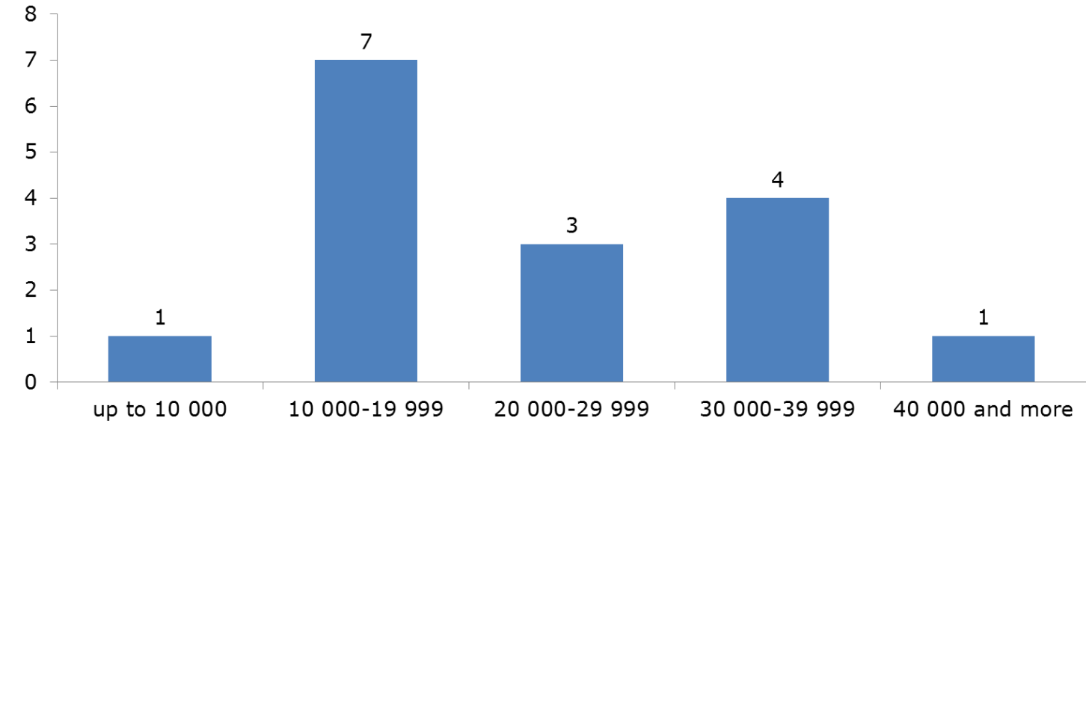

Source: Information system on TCN immigrants’ families / data on families with men aged 16-27

*Table 11: Number of families by share of their income from social security scheme (except pensions) in their total family income*

|  |  |  |  |
| --- | --- | --- | --- |
| Categories of families according to share of their income from social security scheme in their total family income in per cent | | Number of families | |
| All 61 families | Families with young migrant men 16-27 years |
| At least one family member has an income from social security scheme (except pensions) | | 23 | 7 |
| Thereof share of income from social security scheme in total family income in per cent | Less than 10 | 6 | 3 |
| 11-20 | 7 | 2 |
| 21-30 | 5 | 0 |
| 31-50 | 1 | 0 |
| 51-70 | 1 | 1 |
| 71-90 | 0 | 0 |
| 91-99 | 0 | 0 |
| 100 | 3 | 1 |

Source: Information system on TCN immigrants’ families / data on families with men aged 16-27

*Table 12 Income from the CR social security system in families of young migrant men in CZK*

|  |  |  |  |  |  |  |  |  |
| --- | --- | --- | --- | --- | --- | --- | --- | --- |
| Total income from the CR social security scheme | | | Total | Thereof | | | | |
| Less than 2000 | 2000 - 4999 | 5000 - 7999 | 8000-9999 | Over 10 000 |
| Thereof | State social support (child allowance, housing allowance, parental allowance, foster care allowance, birth grant, funeral grant) | | 1 | 1 |  |  |  |  |
| Assistance in material need (allowance for living, supplement for housing, extraordinary immediate assistance) | | 3 |  | 1 | 2 |  |  |
| Social insurance benefits except pensions | | 1 |  |  | 1 |  |  |
| Pensions in the CR in total | | 3 | 1 | 1 |  |  | 1 |
| Thereof | invalidity | 2 | 1 | 1 |  |  |  |
| Orphan´s | 0 |  |  |  |  |  |
| Widow´s or widower´s | 0 |  |  |  |  |  |
| Old-age | 1 |  |  |  |  | 1 |
| other | 0 |  |  |  |  |  |
| Pensions in total | | | 3 | 1 | 1 |  |  | 1 |

Source: Information system on TCN immigrants’ families / data on families with men aged 16-27

***3.3 Barriers to integration of young migrant men***

Research project “Barriers of the integration from the perspective of third country nationals” (D. Schebelle, M. Horáková, 2012, further on Barriers only). The research was based on the assumption that the main qualitative indicators of the barriers to integration of Third Country Nationals can be specified and described by analysing and evaluating the attitudes of foreigners and thus to identify potential positive and negative aspects of their position in the Czech Republic, the relationships of foreigners to the Czech population and the barriers endangering or preventing the process of their integration into society.

Data on young immigrant men were collected in a sociological survey that was performed in 2011. Total 309 respondents from Ukraine (168 respondents), Vietnam (96 respondents) and Russian Federation (45 respondents) were selected according to their representation within total TCN population (quota sample of three most numerous TCN groups). Majority of them were in productive age 35-44 years (65%). Altogether 21 respondents from total sample of 309 respondents were men between 16-27 years, which belong to our target group. 52 % were older than 24 years. We describe life situation of young migrant men in the CR on a basis of this selected group of respondents.

*Table 13 Age structure of selected sample of respondents in Barriers research in 2011*

|  |  |  |
| --- | --- | --- |
| Age | Absolute figures | Per cent |
| 16 | 1 | 4.8 |
| 17 | 1 | 4.8 |
| 18 | 3 | 14.3 |
| 20 | 1 | 4.8 |
| 22 | 2 | 9,5 |
| 24 | 2 | 9,5 |
| 25 | 2 | 9,5 |
| 26 | 4 | 19,0 |
| 27 | 5 | 23.8 |
| total | 21 | 100.0 |

Source: Barriers of the integration from the perspective of Third Country Nationals (D. Schebelle, M. Horáková, 2012).

Selected sample of young migrants included 12 Ukrainians, 5 Vietnamese and 4 Russian respondents between ages 17-27. Mostly (18 respondents) they lived in a big city such as Prague, Brno and Ostrava, 3 respondents lived in towns. 10 respondents came to the CR from cities, 8 from big cities and three from villages of their homeland.

18 of young migrants in our sample lived in the CR over 1 year; therefrom 6 respondents lived in the CR over 10 years, 4 respondents 6-10 years, 5 respondents 3-5 years and 3 respondents 1-2 years. 2 respondents lived less than 1 year in the CR. First time in the CR were 15 respondents, 6 respondents answered that they had already lived in the CR before.

10 young respondents resided permanently, 5 respondents had visa over 90 days, 6 had long-term permit. Main purpose of stay of selected group of young migrants was employment (10 respondents) or study (9 respondents), 1 respondent had his own business and only 1 respondent answered that purpose of his stay is a family reason. The purpose of stay “study” is significantly more important among young migrants than among older respondents 27+.

*Figure 10 Main purpose of residence of young migrants*

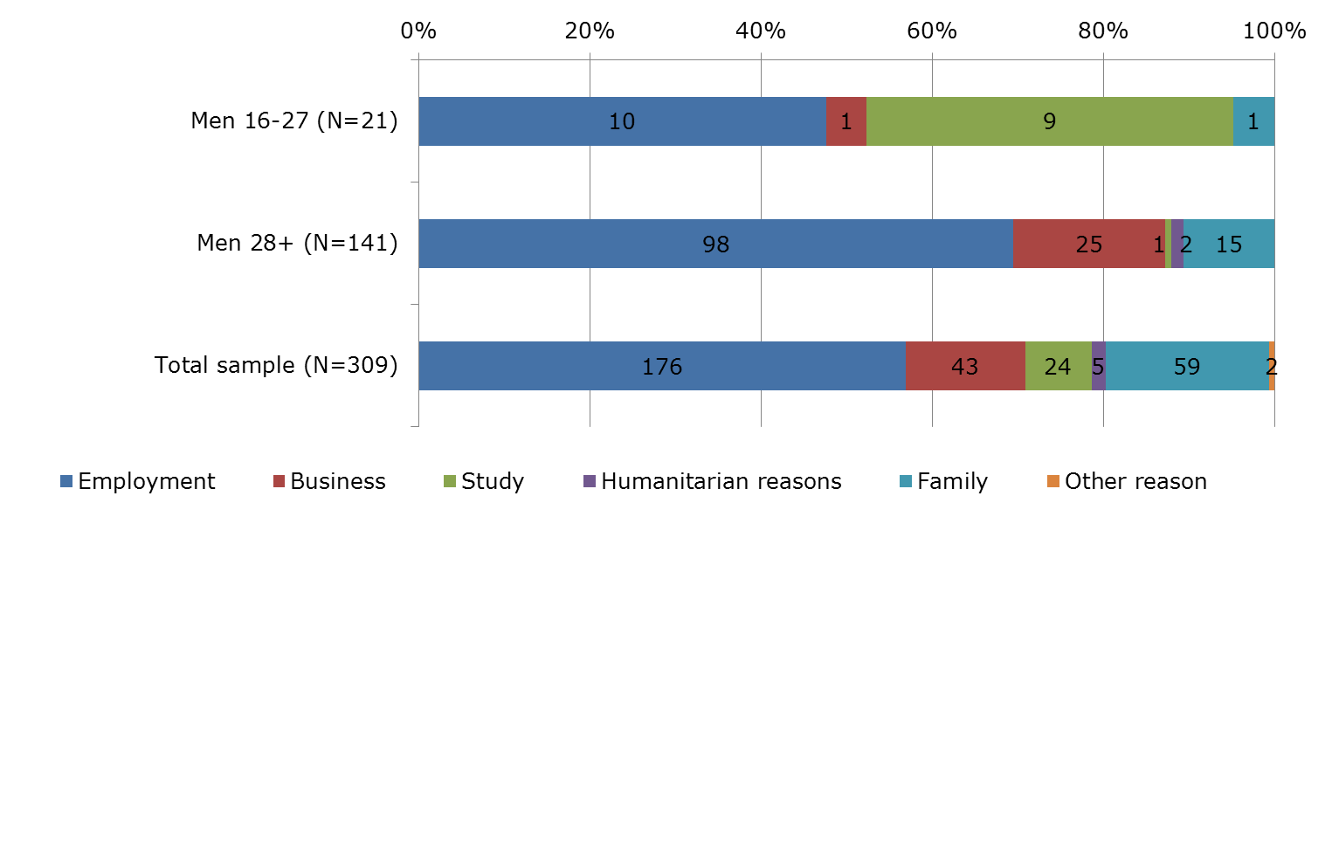

Source: Barriers of the integration from the perspective of Third Country Nationals (D. Schebelle, M. Horáková, 2012).

**State Citizenship**

We consider that the CR citizenship reflects aim of a foreigner to accomplish his/her integration. It should express identification with host society. Consciousness of appurtenance is an important factor which contributes to stability and cohesion of the society. Foreigners in the modern societies often strive for citizenship for pragmatic reasons only; state citizenship gives them complete civil rights and above all guarantees stability of residence, which is very important for social integration. Also it prevents extradition in case of a serious crime.

**During decade 2001–2011** total 33 thousand[13] of foreigners acquired Czech citizenship[14], thereof 12 thousand through naturalisation process. Most numerous groups of new citizens were: former Slovak citizens 12.7 thousand (38.5 %), Polish citizens 1.6 thousand (4.9%), Romanian citizens 1.0 thousand (3%). Most numerous TCN groups were: former Ukrainian citizens 4.2 thousand (12.7%), Russian citizens 866 (2.6%), Kazakhstan citizens 718 (2.2%) and Vietnamese citizens 568 (1.7%). (Source CZSO, Foreigners in the CR 2012, calculations M. Horáková).

**In 2011** total 1.9 thousand foreigners acquired the Czech citizenship. Most numerous TCN nationals who acquired Czech citizenship in 2011 were previous: Ukrainian citizens (25%), Vietnamese citizens (4.4%), Russian Federation citizens (3.5%), Kazakhstan citizens (2.5%), Armenian citizens (2.4%), Belarussian citizens (2%), and Moldavian citizens (1.7%). **In 2012** total 1,565 foreigners acquired CR citizenship. **In 2013** total 4.5 thousands acquired the Czech citizenship.

The new Act on Citizenship No. 186/2013 Coll., which came into the force in January 2014, changed fundamentally rules on acquirement of the CR citizenship. The number of new applicants for citizenship increased significantly. It introduces simplified procedure for those, who were born in the CR territory, and for those who are living in the CR over 10 years[15]. New law enables a possibility to have double or even multiple citizenship simultaneously.

*Table 14 State citizenship of the Czech Republic acquired in 2012*

|  |  |  |  |  |  |
| --- | --- | --- | --- | --- | --- |
| Previous state citizenship | 2012 | | Previous state citizenship | 2012 | |
| Absolute figures | Per cent | Absolute figures | Per cent |
| Total | 4532 | 100,00% | Cuba | 26 | 0,57% |
| Slovakia | 2109 | 46,54% | Bosnia and Herzegovina | 20 | 0,44% |
| Poland | 304 | 6,71% | Greece | 19 | 0,42% |
| Ukraine | 251 | 5,54% | Macedonia | 18 | 0,40% |
| Romania | 109 | 2,41% | Belarus | 13 | 0,29% |
| Bulgaria | 95 | 2,10% | Syrian Arab Republic | 13 | 0,29% |
| Russian Federation | 65 | 1,43% | Armenia | 8 | 0,18% |
| Kazakhstan | 43 | 0,95% | Selected total | 3122 | 68,89% |
| Viet Nam | 29 | 0,64% | Others | 1410 | 31,11% |

(Source CZSO, Foreigners in the CR 2013, calculations M. Horáková).

Research results shows that from group of 17 young migrants who answered question: “Would you like to obtain citizenship of the Czech Republic?”, only 9 respondents declared an interest in getting the Czech state citizenship and 8 respondents declined it[16]; older respondents than 27 years were less interested in the CR citizenship (50%).

*Figure 11 Would you like to obtain citizenship of the Czech Republic?*

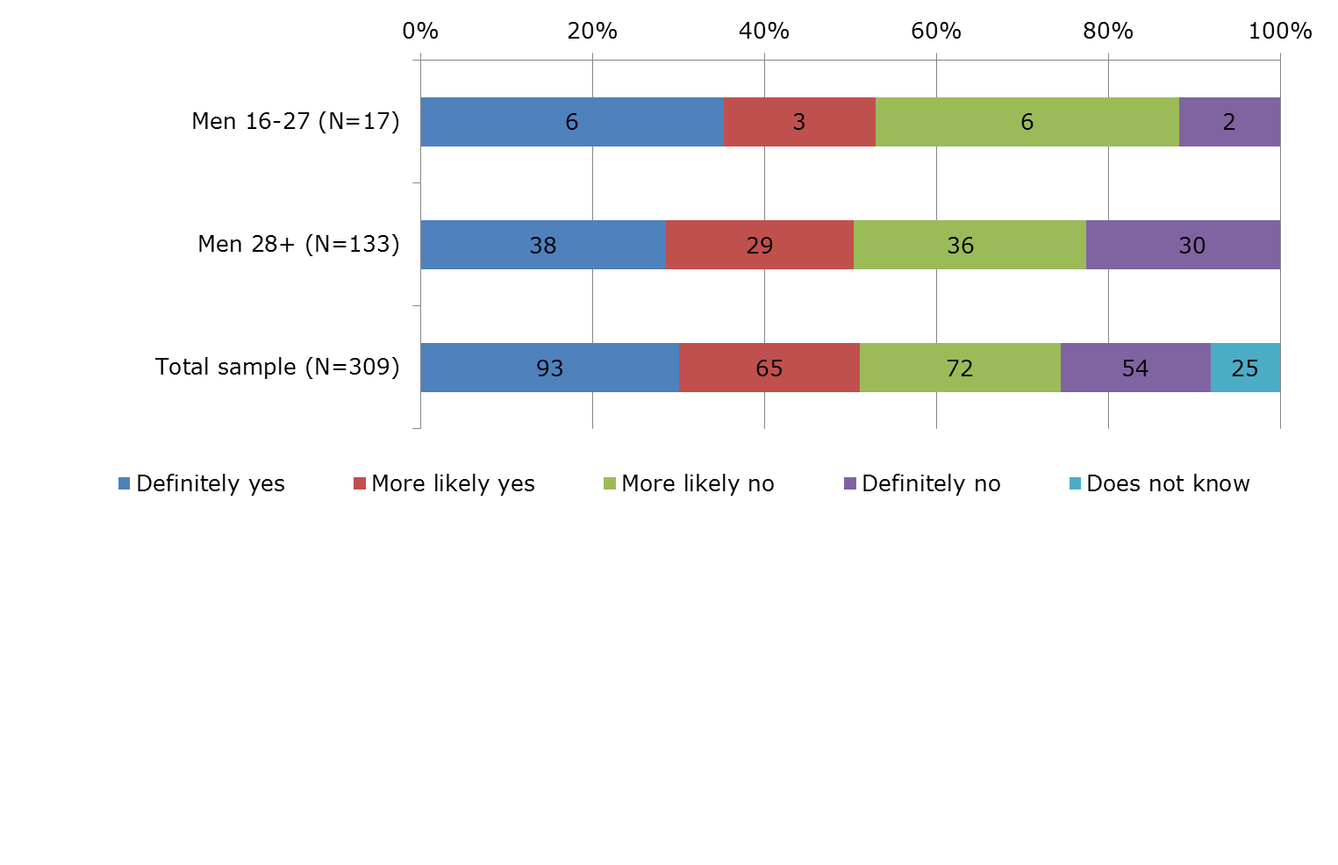

Source: Barriers of the integration from the perspective of Third Country Nationals (D. Schebelle, M. Horáková, 2012).

**Family**

Latest research from area of foreigners’ integration stresses the influence of family in this process. Family saturates basic needs of its members, such as feeling of security, belonging, acknowledgment, and helps them overcome barriers which brings life in a foreign country especially during the first phase of integration process.

Young migrants aged 16-27 selected from sample of research “Barriers” were single, only one was married. They lived altogether in nuclear families with others family members in one flat. They have some social background in the CR, only one of them had neither family nor friend.

Family status influenced an interest in family reunification and wish that their children will grow up in the CR. Interest of young migrants in family reunification was rather low, although they mostly agreed with the opinion, that foreigners’ children have the same chance to finish their studies and find a job in the CR as Czech children.

Half of young migrants wish that their children grow up in the CR, but only one tenth expressed definite consent. We believe that positive attitudes of foreigners toward reunification family and interconnection of family migration with future of children manifests a trust of respondents vis-à-vis the host society.

*Figure 12 Are you interested in re-unification of the family in case your family members are not living with you in the CR but in the country of your origin?*

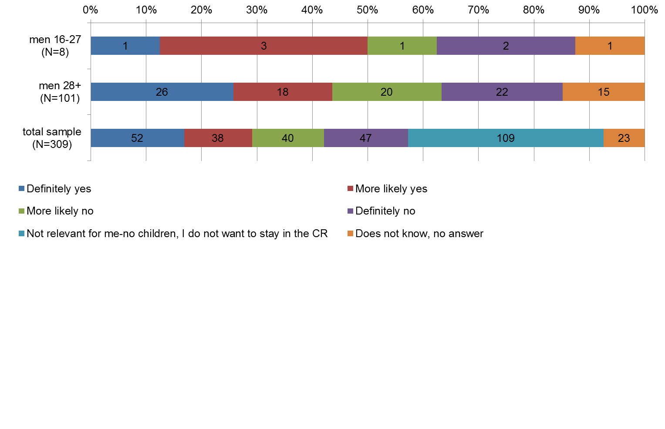

Source: Barriers of the integration from the perspective of Third Country Nationals (D. Schebelle, M. Horáková, 2012).

*Figure 13 Would you like your children to grow up in the CR?*

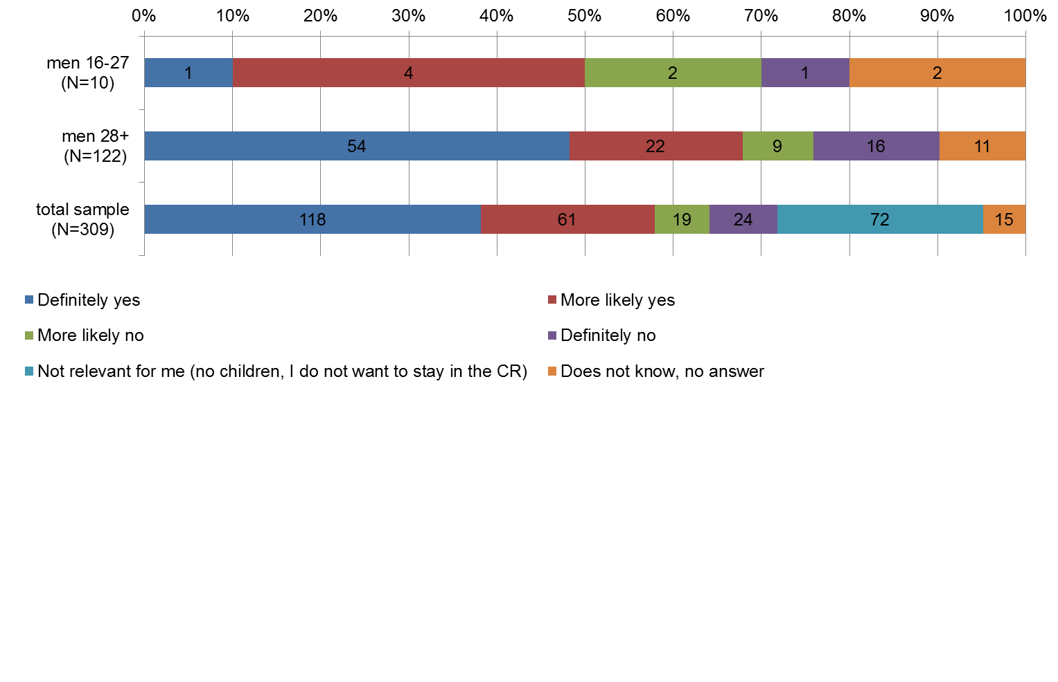

Source: Barriers of the integration from the perspective of Third Country Nationals (D. Schebelle, M. Horáková, 2012).

**Housing**

Young respondents from Barriers research lived in rented flats or houses (10), in own flats or houses (4), in a lodging house (4), two respondents lived with their friends in their room, one respondent lived in a leased room. Their housing was not very different from housing of other respondents.

*Table 15 Could you please tell me where do you live?*

|  |  |  |  |  |
| --- | --- | --- | --- | --- |
| Housing | Total sample n=309 | | Men 16-27 | |
| Frequency | Percent | Frequency | Percent |
| In a leased room | 32 | 10.4 | 1 | 4.8 |
| In a leased flat/house | 159 | 51.5 | 10 | 47.6 |
| In my own flat/house | 51 | 16.5 | 4 | 19,0 |
| In a lodging house | 40 | 12.9 | 4 | 19,0 |
| With friends, relatives | 25 | 8.1 | 2 | 9,5 |
| Somewhere else, please state where | 1 | 0.3 | 0 | 0.0 |
| Does not know, no answer | 1 | 0.3 | 0 | 0.0 |
| Total | 309 | 100.0 | 21 | 100.0 |

Source: Barriers of the integration from the perspective of Third Country Nationals (D. Schebelle, M. Horáková, 2012).

Young migrants from Barriers research lived usually altogether with their household members; 12 of them in four-member household, 3 in two-member household, 2 in five-member household, 2 in six-member household, 1 lived in a hostel with more than 35 people and 1 respondent lived alone. Altogether 7 respondents shared one room with one other person, 7 with two persons, 3 with three persons, 1 with four persons and 2 slept in their room alone.

We received the following answers to the question: *Is any member of your family living with you in the CR in one flat?* 1 respondent lived in one flat with his wife and his child; 9 respondents lived with their parents and 7 respondents lived with their siblings.

To the question: *Are there in the CR more relatives or friends who are not living with you? we* received these answers:2 respondents refer parents, 4 respondents siblings, 10 respondents relatives, 14 respondents friends. Only 1 respondent had neither family member nor friends in the CR.

Households of young migrants are not always unified. Members of one family live in different places probably because they study in the CR in a different place than their parents work or they found a job in a different place from that in which their family lives. Young migrants live usually in rented flat or in own flat or house.

**Trust**

A substantial constituent of the „well-being“ of young migrants is a trust in persons they are in daily contact with. Absence or loss of trust complicates human relations and prevents integration into social structures. Unsatisfied basic psychic needs such as love, recognition and trust in close persons lead to frustration, which in turn is usually a source of aggression, both verbal and physical. This is what we should bear in mind when assessing „well-being“ of young migrants. The respondents across the entire sample trusted mainly in compatriots and majority members (See Graph 2).

Trust in compatriots was for young respondents aged 16-27 years high, even though it was slightly lower than for respondents over 27 years. Trust in majority members was lower than trust in compatriots, but contrary to older respondents young respondents felt no utmost mistrust vis-a-vis majority. Surprisingly they trusted to officials handling residence permits, older respondents were vis-à-vis them more cautious. Trust in foreigners of young interviewed immigrants had a contact with came across in daily life, was compared to trust in majority and compatriots much lower, for respondents over 27 years it was even lower (39,7%).

*Figure 14 Trust in total sample 309 respondents*

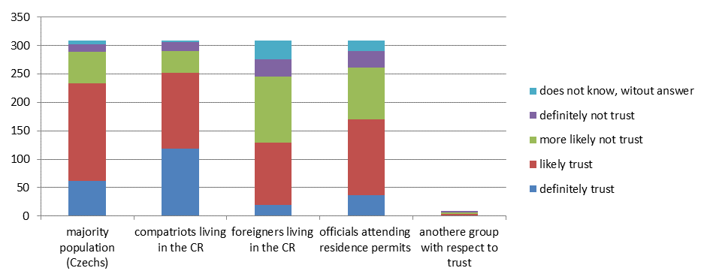

Source: Barriers of the integration from the perspective of Third Country Nationals (D. Schebelle, M. Horáková, 2012). ¨

**Discrimination**

Discrimination can change the climate, life, and relationships inside a family and modify the behaviour of individual family members within and outside the family. The effects of discrimination on the inner life of the family and the influence on the external families’ relationships with their wider social environment can vary greatly according to research results[17]. Perceived prejudice and discrimination influence life of young migrants, affect their self-evaluation. It could be unpredictable social stressor and could bring psychological or psychiatric problems. It could lead to protest and militancy and agitation for social change by those on the receiving end of intolerance. Another predictable consequence or correlate of perceived prejudice and discrimination should be increased identification with one’s own group/the counterpart in the individual to greater cohesion in the larger group. Identifying with one’s own group (or in-group) and receiving support from it should ultimately reduce stress resulting from discrimination (Dion, Kenneth, 2001)[18].

Discrimination is a wide-spread problem facing not only migrants. It has various forms, intensity and consequences. Perceived discrimination is a strong barrier to integration. Research results confirm some previous findings, that it is not a sporadic phenomenon. Over one third (35%) of the total sample of respondents were personally exposed to discrimination; 65% stated that they never encountered anything like that. Discrimination in a sense of unequal treatment, refusal or bullying was among young migrants substantially lower than in the entire sample of respondents. It was experienced by those whose main purpose of stay in the CR was employment (3), in sporadic cases those whose purpose of stay was study (1) or family reasons (1). Most frequently men aged 28+ were subjected to discrimination, above all those whose main purpose of stay was employment (46%) or business (40%).

In interviews we inquired not only about experience of respondents with discrimination, but also about form and intensity of experienced discrimination. Total 5 young migrants out of 21 migrants in the age group 16-27 years encountered some form of discrimination. Not always it was the disadvantage of the same intensity. Serious forms of certain types of discrimination were recorded in answers of respondents 13 times, soft discrimination form 4 times. Detailed list of different discrimination types including discrimination intensity shows Figure 16.

Only 18 respondents from the entire sample of 309 respondents tried to tackle discrimination somehow and 39 were considering doing that; among young migrants there was just one respondent trying to tackle this and just one considering such option; among respondents over 28 years corresponding values were 12 respondents, 25 considering doing it. Majority of respondents did nothing with discrimination because they were either afraid of worsening situation or because they did not believe in remedy. Young migrants probably cannot face the discrimination acts. If only one respondent out of five tried to defend himself and one thought about it but did nothing, it means a challenge to stakeholders. Training in this area should certainly improve situation of young migrants and their „well-being“.

*Figure 15 Have you personally encountered a discrimination i.e. unequal treatment, refusal, bullying at work or in business?*

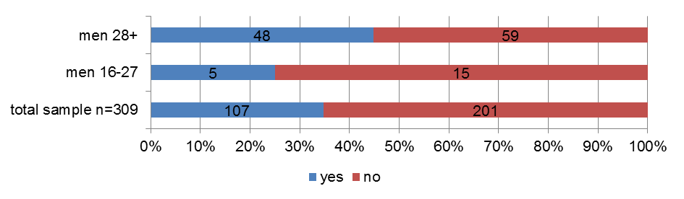 Source: Barriers of the integration from the perspective of Third Country Nationals (D. Schebelle, M. Horáková, 2012).

*Figure 16 What form of discrimination in particular was/is it?*

1. *Paid less than other fellow workers*

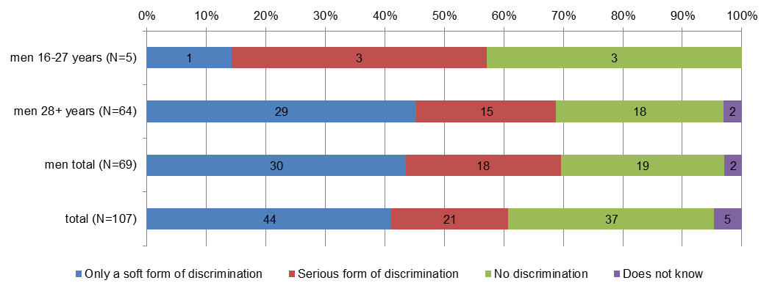

1. *Assigned more work than other fellow workers*

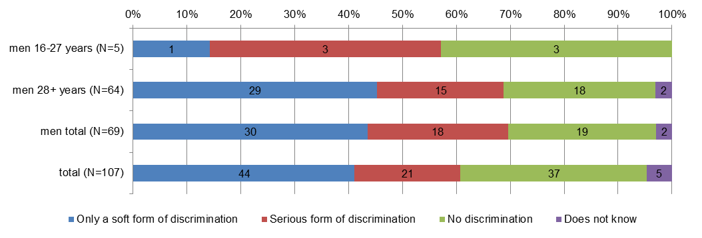

1. *Work for longer period than other fellow workers*

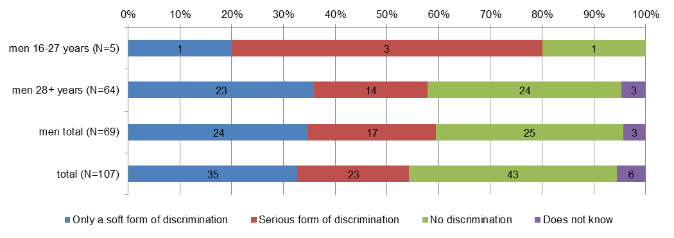

1. *More often allocated inconvenient shifts (i.e. only night ones)*

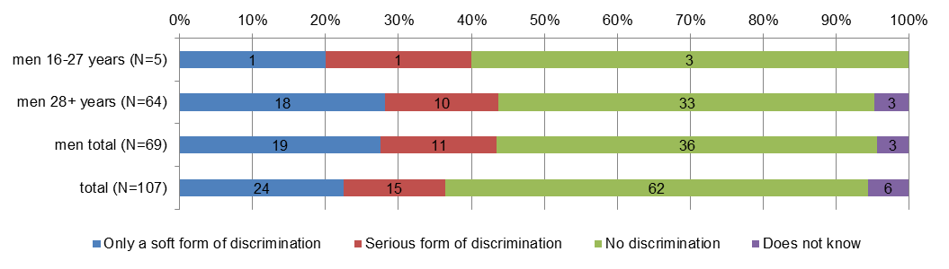

1. *More often allocated dangerous, risky and unwholesome work*

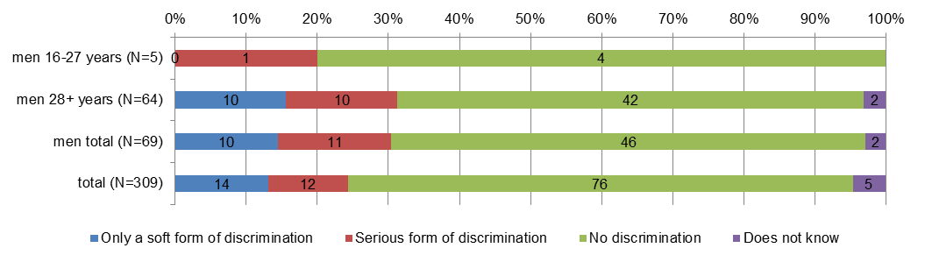

1. *Access to tenders was not the same like that of other entrepreneur*

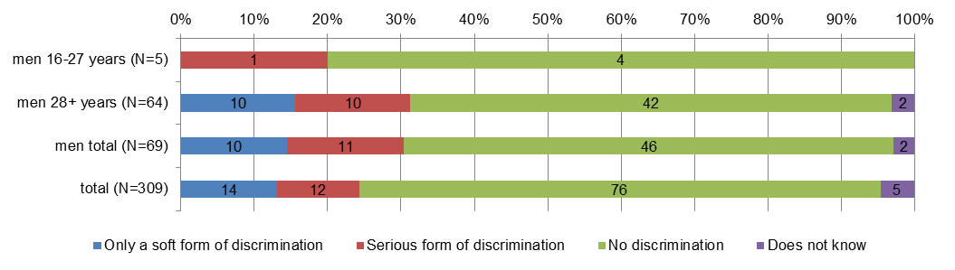

1. *Was bribed, a "ransom" was required*

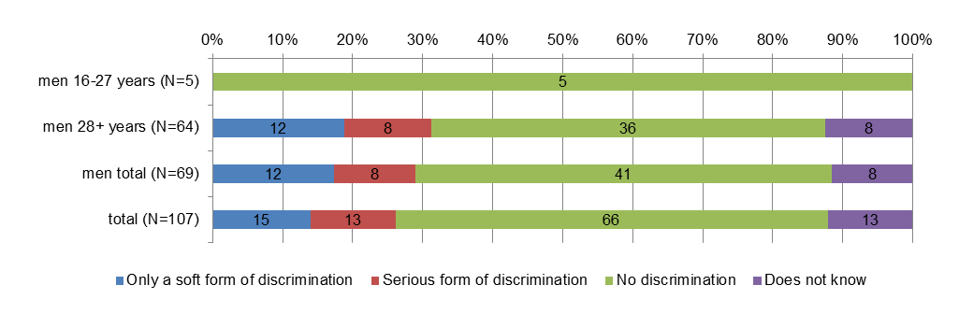

Source: Barriers of the integration from the perspective of Third Country Nationals (D. Schebelle, M. Horáková, 2012).

Young migrants - men did not experience discrimination as often as older migrants - men; but if they encountered discrimination, it was more often a serious form of discrimination especially in work place; they were less paid than other fellow workers, they were assigned more work than other fellow workers, they worked for longer period (more hours) than others, they were more often allocated inconvenient shifts (i.e. only night ones), they were more often allocated dangerous, risky and unwholesome work and especially their access to tenders was not the same like that of other entrepreneurs. Our sample of young migrant men was rather small. For that reason we can only signalize that young migrants men could face serious discrimination problem especially in business and in employment and they do not know how to react adequately to it.

*Figure 17 If you encountered discrimination but did nothing, it was because:*

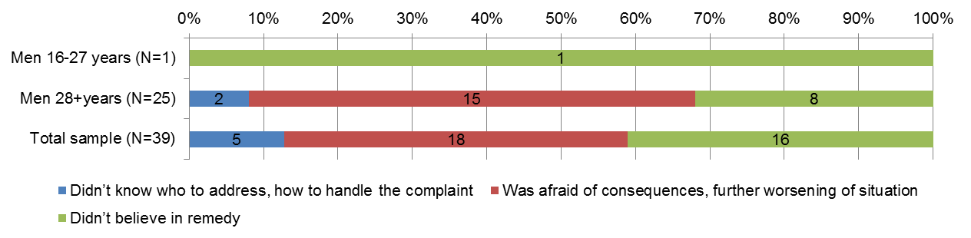

Source: Barriers of the integration from the perspective of Third Country Nationals (D. Schebelle, M. Horáková, 2012).

*Figure 18 How often these incidents occurred and where?*

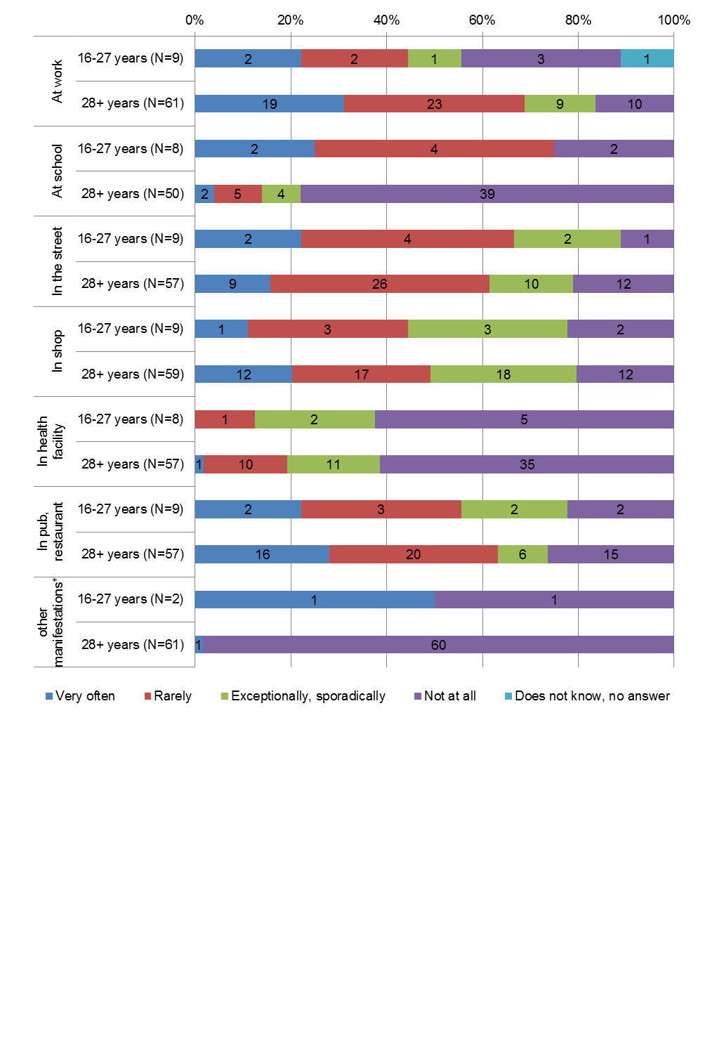Source: Barriers of the integration from the perspective of Third Country Nationals (D. Schebelle, M. Horáková, 2012).

* Another form of jibes, abusive remarks, insults

**Jibs, abusive remarks, and insults in public**

Nine young migrants answered, that they personally encountered jibs, abusive remarks and insults in public, twelve respondents had no such experience.

Responses of young migrants were similar as responses of older migrant men and responses of total sample of respondents (43% answered yes, 57% answered no). Young men 16-27 years were less abused than men 28+ years. Less verbal attacks took place at school and at health facilities. Respondents were mostly verbally abused at work and at pub or beer house. One young respondent was assaulted on the street. It was the most serious incident recorded in Barriers research.

**Sense of belonging**

Feeling of an individual that he is not accepted by neighborhoods, that he is not an equal part of society, creates a significant barrier to integration. It may lead to frustration and eventually to some form of aggression.

*Question: Does it happen to you that majority people (Czechs) from your neighborhoods show that you don’t belong to them, that you are alien?* One half of young migrants answered yes, one half no. Discovered differences between age groups of respondents were rather negligible. About 50 % of respondents felt and experienced social distance. Young migrants expressed less radical consent.

*Question: To which area these people belong?* Within group of men 17-27 in 5 cases these people belong to fellow workers from majority, in 5 cases they are people from majority, in 3 cases neighbours from majority, in 2 cases other foreigners living in the CR and in 1 case it is a compatriot.

*Figure 19 Does it happen to you that majority people (Czechs) from your neighborhood show that you don’t belong to them, that you are alien?*

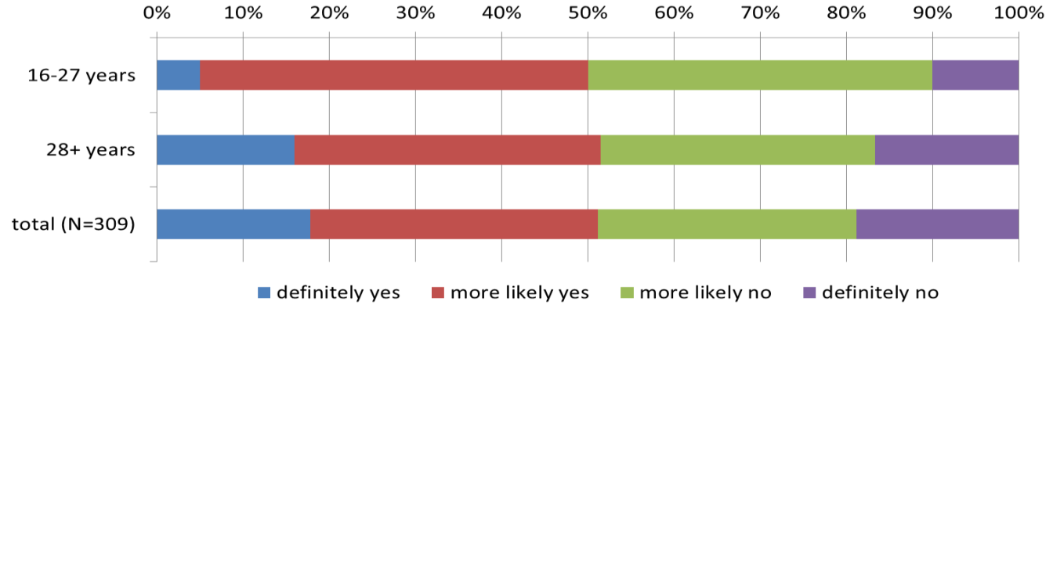

Source: Barriers of the integration from the perspective of Third Country Nationals (D. Schebelle, M. Horáková, 2012).

**Adaptation**

Young migrants felt that majority expects them to fully adapt to values of the Czech society. Similar was response of older respondents. From responses of young migrants it can be judged that they are more adaptable (compared to older migrants) and do not adhere so much to ways of life brought from their home country.

Language barrier was for young migrants aged 16-27 years lower than for older respondents. Half of young migrants said that adaptation to the Czech language environment was for them rather difficult, but only one had serious problems with Czech; older respondents experienced more serious problems with the Czech language. It depended on from which culture they came from. Also, young migrants were better adapting to food culture than older respondents. Adaptation to work environment was also better than for older respondents. Also young migrants could handle attending to official matters with authorities better than older respondents.

Young respondents were adapting easier than older ones to Czech customs and way of life. They had no problems with life in cities, towns or villages. Even though they suffered (like other interviewed migrants) from homesickness, but not so intensively like older respondents. Half of young migrants were missing family and friends, but more than half of older respondents were missing their family and friends.

*Figure 20 Do you feel that majority expects from you that you will fully adapt to values of the Czech society?*

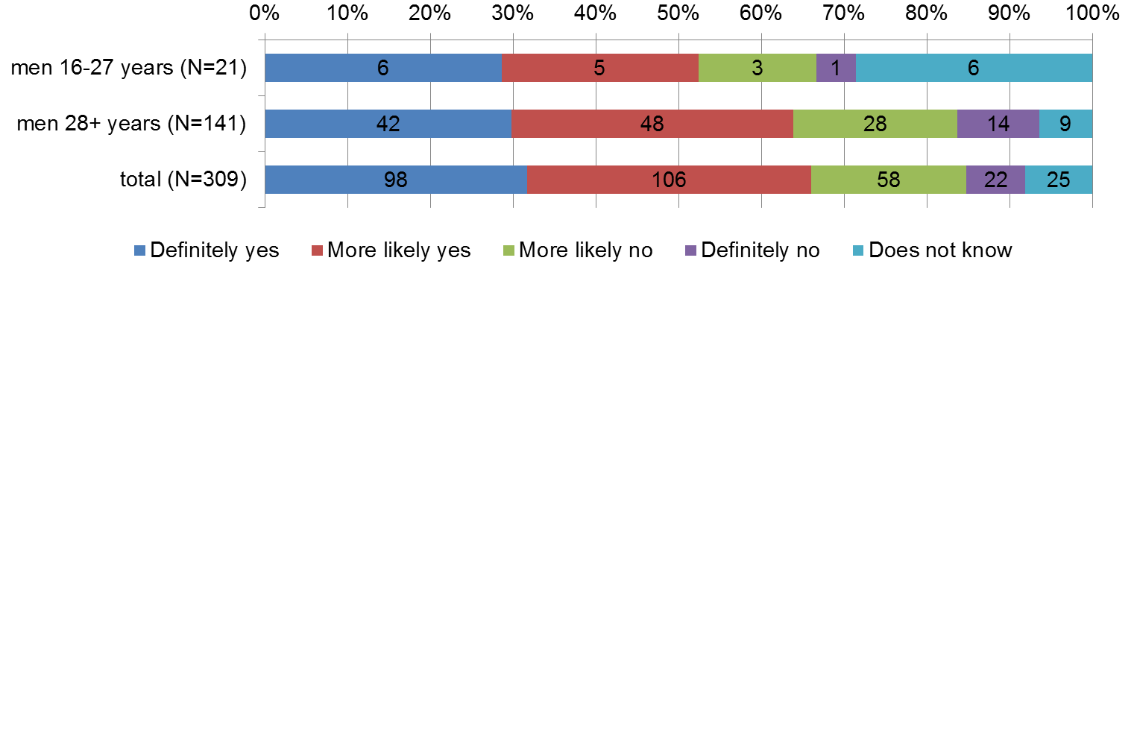

Source: Barriers of the integration from the perspective of Third Country Nationals (D. Schebelle, M. Horáková, 2012).

*Figure 21 Life in the Czech Republic is probably different from life in the country of your origin/birth/longest stay. With adaptation to what you have difficulties, what is difficult for you to overcome?*

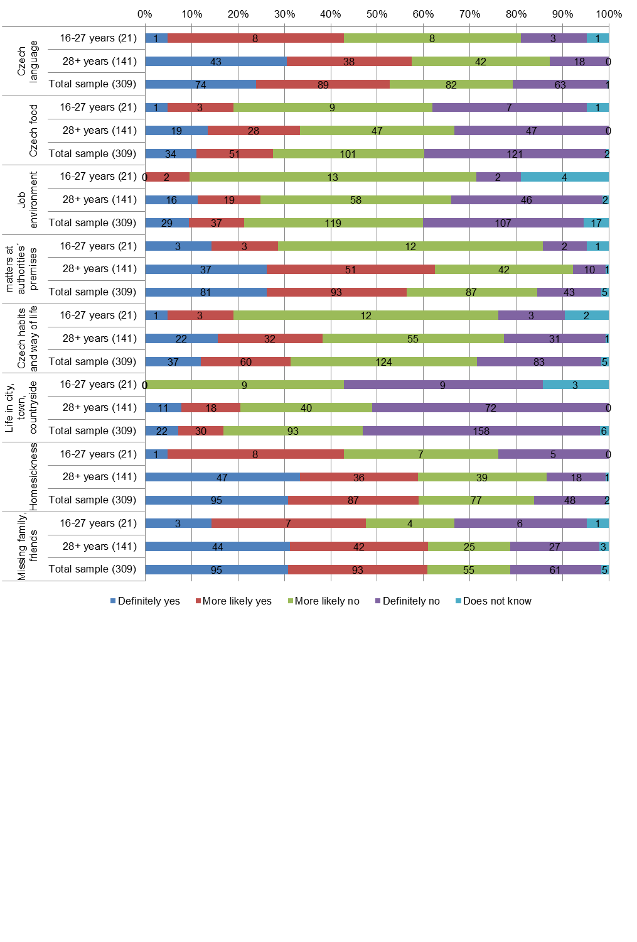

Source: Barriers of the integration from the perspective of Third Country Nationals (D. Schebelle, M. Horáková, 2012).

**Social contacts**

Young migrants have rather intensive social contacts with compatriots at their leisure. Ten of them meet compatriots every day, seven at least once a week, three at least once a month, one respondent answered that less than once a year. Social contacts with members of majority are even more intensive. Thirteen meet Czechs every day, five once a week, three once a month. Contacts with other foreigners living in the CR were less intensive. Only three respondents 16-27 meet other foreigners every day, two at least per month and sixteen not at all. If they meet other foreigners, two respondent stated Slovaks, one respondent mentioned Brits, one Russians and one other foreigners, mostly from post-communist countries.

**Troubles**

Young migrants know who to contact should they get into difficulties in the CR, four of them do not know it. Eight young migrants mentioned family members or relatives, seven mentioned friends, four of them introduced police, and four head of school, two mentioned compatriots, two city counsillors, two Ministry of the Interior, department for asylum and migration policy, two ambassadors, one mentioned ombudsman, one majority members, one customs administration.

**Czech language knowledge**

Seventeen young migrants answered, that they speak and understand Czech very well, four answered, that they do not speak Czech very well. Written knowledge of Czech language was not so good; nine young migrants answered, that they understand to written Czech very well, ten of them do not understand to written Czech very well and two do not understand to written Czech at all. Seven young migrants answered that they write very well Czech, nine not very well Czech, four that they do not write Czech at all, and one answered, that he does not need write in Czech. Five young respondents learned Czech prior to their arrival to the CR, nine not. Nineteen learned Czech language after their arrival to the CR, two not, four not at all and one answered, that he does not need to write in Czech. Five young respondents learn Czech language prior their arrival to the CR, nine not. Nineteen learned Czech language after their arrival to the CR, two did not.

Young migrants learned Czech usually in company of their Czech friends (16), at work with Czechs (11), at school (10), two in free of charge Czech language courses and four in paid language courses.

**Education**

In the CR 15.7% of total residing foreigners visited some school or university during school year 2012/2013; the same indicator for total CR population was 18.8 %. Participation of foreigners in the CR education system increase year by year. Most foreigners studied in school year 2012/2013 at universities[19] (39 695) and they made 11.6 % of total students studying during this school year in the CR universities. During last decade number of foreigners - university students increased significantly[20]. Share of foreigners in higher professional schools was 1.8 %, in secondary schools 2%, in conservatories 4.9%, in basic schools 1.8 %, in nursery schools 1.6%, during school year 2012/2013. During school year 2010/2011 total 7 550 graduates (i.e. 8.1%) of the total number of public and private university students were foreigners. During last decade the number of university students increased more than three times[21]. Total 15.7% of foreigners visited some school or university in the CR during school year 2012/2013, in the total CR population it was 18.8 %.

*Table 16 Foreigners - children, pupils and students at nursery schools, basic secondary and higher professional schools and conservatories by citizenship, school year 2012/2013*

|  |  |  |  |
| --- | --- | --- | --- |
| Type of school/university | Total foreigners | The CR population | Share of foreigners in total number of pupils/students (%) |
| Nursery schools | 5 434 | 348 906 | 1.56 |
| Basic schools | 14 551 | 793 399 | 1.83 |
| Secondary schools | 9 024 | 461 701 | 1.95 |
| Conservatories | 169 | 3 460 | 4.88 |
| Higher professional schools | 510 | 28 465 | 1.79 |
| Universities | 39 696 | 341 599 | 11.62 |
| Total | 69 384 | 1 977 530 | 3.51 |

Source: Foreigners in the CR 2011. CZSO.

High number of foreign university students demonstrates that for young migrants it is relatively easy to become university students. They can study not only in Czech, but also in a foreign language. Often studies are a way how to evade problems in a home country (e.g. conscripts) and for some young men a residence permit for study purpose is a hidden entry point to labour market.

*Table 17 Highest achieved education of respondents of Barriers research*

|  |  |  |  |  |
| --- | --- | --- | --- | --- |
| Highest achieved education | Total sample n=309 | | Men 17-27 years | |
| Frequency | Percent | Frequency | Percent |
| Basic education including unfinished, practical school without trade licence | 46 | 14.9 | 7 | 33.3 |
| Trade licence with or without graduation | 97 | 31.4 | 5 | 23.8 |
| Higher professional school with graduation | 81 | 26.2 | 5 | 23.8 |
| Secondary school with graduation | 43 | 13.9 | 4 | 19,0 |
| University (all degrees) | 41 | 13.3 | 0 | 0.0 |
| Does not know, didn’t respond | 1 | 0.3 | 0 | 0.0 |
| Total | 309 | 100.0 | 21 | 100 |

Source: Barriers of the integration from the perspective of Third Country Nationals (D. Schebelle, M. Horáková, 2012).

Level of young migrants’ education need not be a barrier for their further employment. Employers ask often for unskilled labour foreigners because they search for cheapest labour force. If they find a foreigner with professional skills, they are moreover profiting from the fact that they employ him as an unskilled worker.

Education level of young migrants 16-27 years from the Barriers research was following; 7 respondents finished basic education, 5 got trade licence without graduation, 5 finished higher professional schools with graduation and 4 finished secondary general schools with graduation. No respondent finished university.

**Employment**

Young migrants from Barriers research worked in the CR mostly as employees (11, therefrom 7 for employers and 4 for labour agencies), one had business; 5 young migrants were helping out in a family business but only one worked for wage[22]. 3 respondents did not work, but one of them was interested in working. Compared to the entire sample of respondents they helped out in family businesses without demand on wage (See Annex II Tab. 23).

Six respondents from the age group 16-27 years were doing in the CR quite different work compared to what they were doing a country of their origin, two only slightly different work and four the same work like before their arrival into the CR. In the entire sample of respondents there were 60% of those doing quite different work, 21% % of those doing slightly different work and only 10% of those doing the same work like before their arrival into the CR. Ten out of twenty one concluded a work contract with their employer, two respondents did not conclude a written contract[23], and two respondents had businesses. Seven respondents responded that they do not need any written contract with their employer.

Fifteen respondents out of twenty one were satisfied or more likely satisfied with their work in the CR. In the total sample of respondents there were 73% of those who were satisfied with their work in the CR. Eight respondents aged 16-27 let (from twenty one) said that they wish to find another job. Five respondents contemplated leaving the CR should they not find better job. Among attributes of so called ”better job” was primarily wage (ten respondents). From this point of view young migrants (16-27 years) do not differ from the entire sample of respondents.

Wage is one of the most important factors affecting job satisfaction. Wages of young migrants discovered in Barriers research were relatively very low. One respondent had net monthly income CZK 14,000 (ca EUR 509)[24], one CZK 13,000 (ca EUR 473), three respondents CZK 12,000 (EUR 436), one respondent CZK 10,000 (EUR 364), one CZK 7,000 (EUR 255), one CZK 5,000 (EUR 182), one CZK 3,000 (EUR 109), and one CZK 2,000 (EUR 73).

More specific data about duration of working time of respondents and number of hours worked are not available. Currently, minimum wage in the CR is CZK 8,500 (gross), i.e. EURO 309; basic hourly rate is CZK 50.6 per hour (ca EURO 2). Only three respondents (out of ten stating their net wage), earned more than minimum wage. 8% of the entire sample worked for wage not exceeding CZK 9,999 (EURO 365), wage between CZK 10,000 EURO 365) and 14,999 (EURO 509) earned 27% of respondents.

|  |  |  |  |  |
| --- | --- | --- | --- | --- |
| *Table 18 What is type of your employment in the Czech Republic? We mean also occasional and seasonal work, such as brigade-work.* | | | | |
| Type of economic activity | Total sample n=309 | | Men 16-27 years n=21 | |
| Frequency | Percent | Frequency | Percent |
| A work contract with an employer | 115 | 37.2 | 7 | 33.3 |
| Employer of a labour agency (contract with a labour agency) | 43 | 13.9 | 4 | 19.0 |
| In business on a trade licence | 86 | 27.8 | 1 | 4.8 |
| Helping out in a family business, with no income | 19 | 6.1 | 5 | 23.8 |
| Working in a family (own or another) for a wage | 21 | 6.8 | 1 | 4.8 |
| Not working (no income, even no brigade-work) | 15 | 4.9 | 2 | 9.5 |
| Not working but he would like to work | 11 | 3.6 | 1 | 4.8 |
| Does not know, no answer | 2 | 0.6 | 0 | 0.0 |
| Answers total | 312 | 101.0 | 21 | 100.0 |

Source: Barriers of the integration from the perspective of Third Country Nationals (D. Schebelle, M. Horáková, 2012).

*Table 19 Have you concluded a work contract with your employer?*

|  |  |  |  |  |
| --- | --- | --- | --- | --- |
| Written work contract with employer | Total sample n=309 | | Men 16-27 years n=21 | |
| Frequency | Percent | Frequency | Percent |
| Yes | 138 | 44,7 | 10 | 47,6 |
| No | 44 | 14,2 | 2 | 9,5 |
| Not relevant, need not written contract with an employer | 54 | 17,5 | 7 | 33,3 |
| Entrepreneur on a trade licence | 67 | 21,7 | 2 | 9,5 |
| Total | 309 | 100,0 | 21 | 100,0 |

Source: Barriers of the integration from the perspective of Third Country Nationals (D. Schebelle, M. Horáková, 2012).

*Table 20 Are you satisfied with your work in the Czech Republic?*

|  |  |  |  |  |
| --- | --- | --- | --- | --- |
| Satisfaction with work in the CR | Total sample n=309 | | Men 16-27 years n=21 | |
| Frequency | Percent | Frequency | Percent |
| Definitely yes | 106 | 34,3 | 5 | 23,6 |
| More likely yes | 120 | 38,8 | 10 | 47,6 |
| More likely no | 42 | 13,6 | 1 | 4,8 |
| Definitely no | 11 | 3,6 | 1 | 4,8 |
| Does not know, no answer | 2 | 0,6 | 4 | 19,2 |
| Total | 309 | 100,0 | 21 | 100,0 |

Source: Barriers of the integration from the perspective of Third Country Nationals (D. Schebelle, M. Horáková, 2012).

*Table 21 Do you wish to find another job instead of your present one?*

|  |  |  |  |  |
| --- | --- | --- | --- | --- |
| Wish to find another job | Total sample n=309 | | Men 16-27 years n=21 | |
| Frequency | Percent | Frequency | Percent |
| Definitely yes | 44 | 14,2 | 6 | 28,6 |
| More likely yes | 49 | 15,9 | 2 | 9,5 |
| More likely no | 86 | 27,8 | 4 | 19,0 |
| Definitely no | 89 | 28,8 | 1 | 4,8 |
| Does not know, no answer | 13 | 4,2 | 5 | 23,8 |
| Missing | 28 | 9,1 | 3 | 14,3 |
| Total | 309 | 100,0 | 21 | 100,0 |

Source: Barriers of the integration from the perspective of Third Country Nationals (D. Schebelle, M. Horáková, 2012).

*Table 22 Imagine you could better job. Please choose from the list below maximum 3 attributes, that your job should fulfil.*

|  |  |  |  |  |
| --- | --- | --- | --- | --- |
| Attributes | Total sample n=309 | | Men 16-27 yearsn=21 | |
|  | Frequency | Percent | Frequency | Percent |
| Better paid job than my current job | 192 | 30,0 | 10 | 25,0 |
| Less physically strenuous | 75 | 11,7 | 3 | 7,5 |
| With working hours not exceeding eight hours daily | 64 | 10,0 | 3 | 7,5 |
| Without night working shifts | 23 | 3,6 | 1 | 2,5 |
| Without work on Saturdays, Sundays, and holidays | 71 | 11,1 | 4 | 10,0 |
| Less stressful | 39 | 6,1 | 2 | 5,0 |
| Less risky (from the point of view of possible injury or harmful environment) | 24 | 3,8 | 3 | 7,5 |
| Less monotonous, more creative, diverse | 47 | 7,3 | 3 | 7,5 |
| More responsible | 26 | 4,1 | 2 | 5,0 |
| Permanent work for a given period | 60 | 9,4 | 9 | 22,5 |
| Other | 12 | 1,9 | 0 | 0,0 |
| Does not know, no response | 7 | 1,1 | 0 | 0,0 |
| Total | 281 | 100,0 | 40 | 100,0 |

Source: Barriers of the integration from the perspective of Third Country Nationals (D. Schebelle, M. Horáková, 2012).

**Covering cost of living**

Despite low income of respondents, households in which they live, have rather sufficient financial means for covering their cost of living. Sixteen respondents from twenty one stated that household income is easily sufficient for covering cost of food, ten that it is easily sufficient for covering cost of housing, nine that it is easily sufficient for covering cost of clothes, for thirteen the income is sufficient for covering cost of commuting to work, for seven the household income is sufficient for covering cost of commuting to school, for eight it is sufficient for covering leisure costs (see Tab.28).

*Table 23 What is your net monthly income from employment or business in CZK?*

|  |  |  |  |  |
| --- | --- | --- | --- | --- |
| Net monthly income | Total sample n=309 | | Men 16-27 years | |
| Count | % | Count | % |
| Under 9,999 (EUR 364) | 15 | 4,9 | 4 | 19,2 |
| 10,000-14,999 (EUR 364-544) | 51 | 16,5 | 6 | 28,7 |
| 15,000-19,999 (EUR 545-727) | 59 | 19,1 | 0 | 0 |
| 20,000 – 29,999 (EUR 728-1,055) | 49 | 15,9 | 0 | 0 |
| Over 30,000 (EUR 1,091) | 12 | 3,9 | 0 | 0 |
| No income | 95 | 30,7 | 11 | 52,1 |
| No response | 28 | 9,1 | 0 | 0,0 |

Source: Barriers of the integration from the perspective of Third Country Nationals (D. Schebelle, M. Horáková, 2012).

*Figure 22 Is your household income sufficient for easy covering of basic cost of living, for example food, housing, clothes, commuting cost to work, school, leisure etc.*

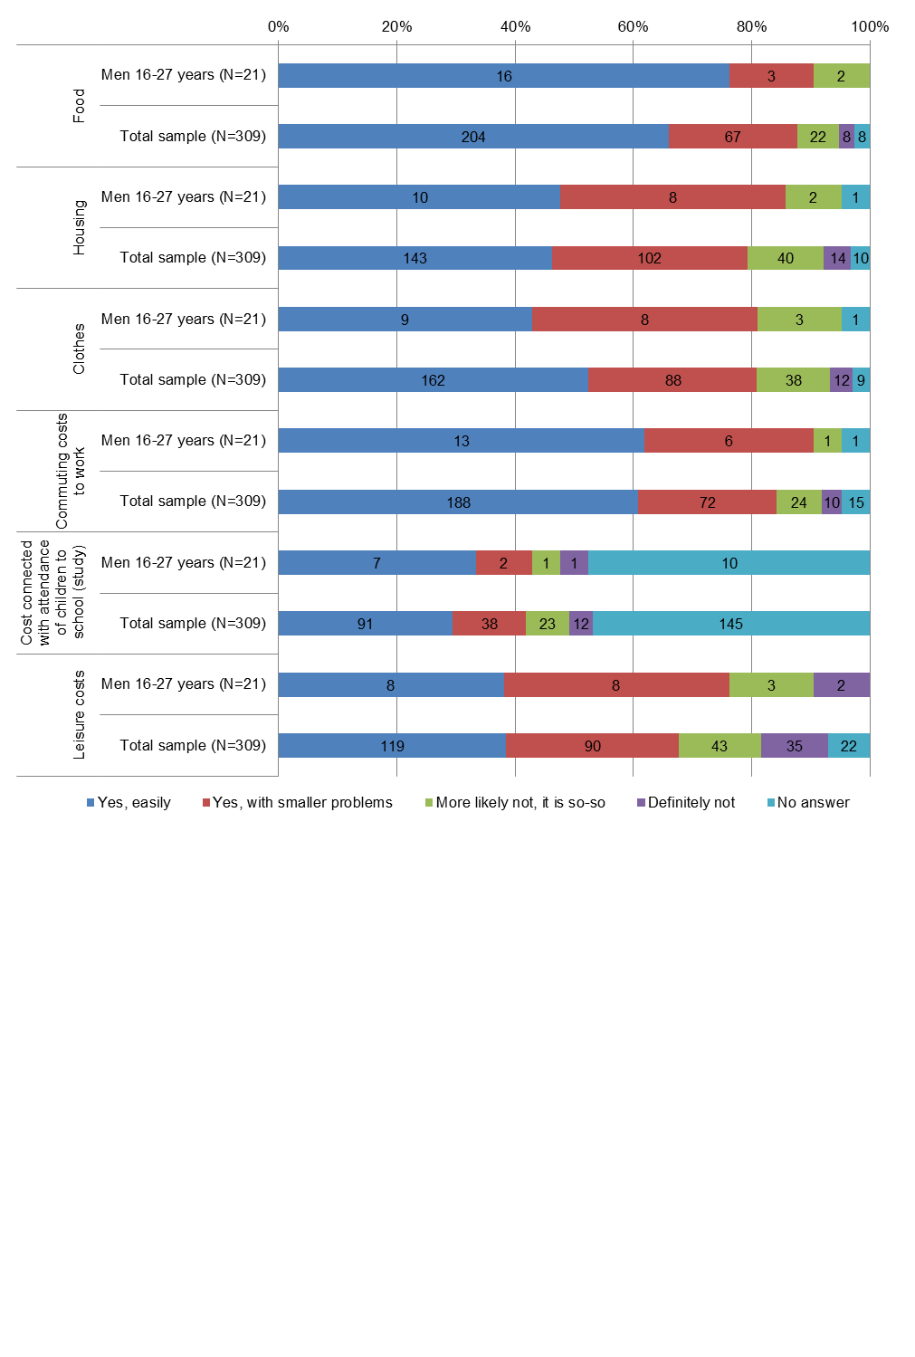Source: Barriers of the integration from the perspective of Third Country Nationals (D. Schebelle, M. Horáková, 2012).

Income of most of household, in which young respondents live, suffices mostly for covering basic living needs, least financial means remains for leisure activities. This may complicate to young migrants aged 16-27 years in a way their inclusion among their contemporaries, and not only from majority society.

**Socio-cultural and political participation**

No respondent between 19-27 years is a member of a sociocultural or national organisation active in the CR. In total sample of 309 respondents it was ten persons.

Only two respondents (from total 21) wish to influence matters of foreigners living in the CR. In total sample of 309 respondents it was 19 %.

Five young respondents would welcome possibility of taking part in local elections in the CR. Within total sample of 309 respondents it was 20%.

Four respondents would welcome possibility of taking part in national elections in the CR. Within total sample of 309 respondents it was 21%. Only two young respondents would like to become a member of a political party active in the CR. Within total sample of 309 respondents it was 7%.

**Fears**

Most important for young migrants are social contacts and stability of their residence status. Young respondents are afraid in the Czech Republic above all of: loss of friends (or long distances), loss of residence permit, loss of income, loss of purpose of stay and expatriation, brake-up of family, serious illness, and loss of health insurance.

*Figure 23 What are you afraid of in the Czech Republic?*

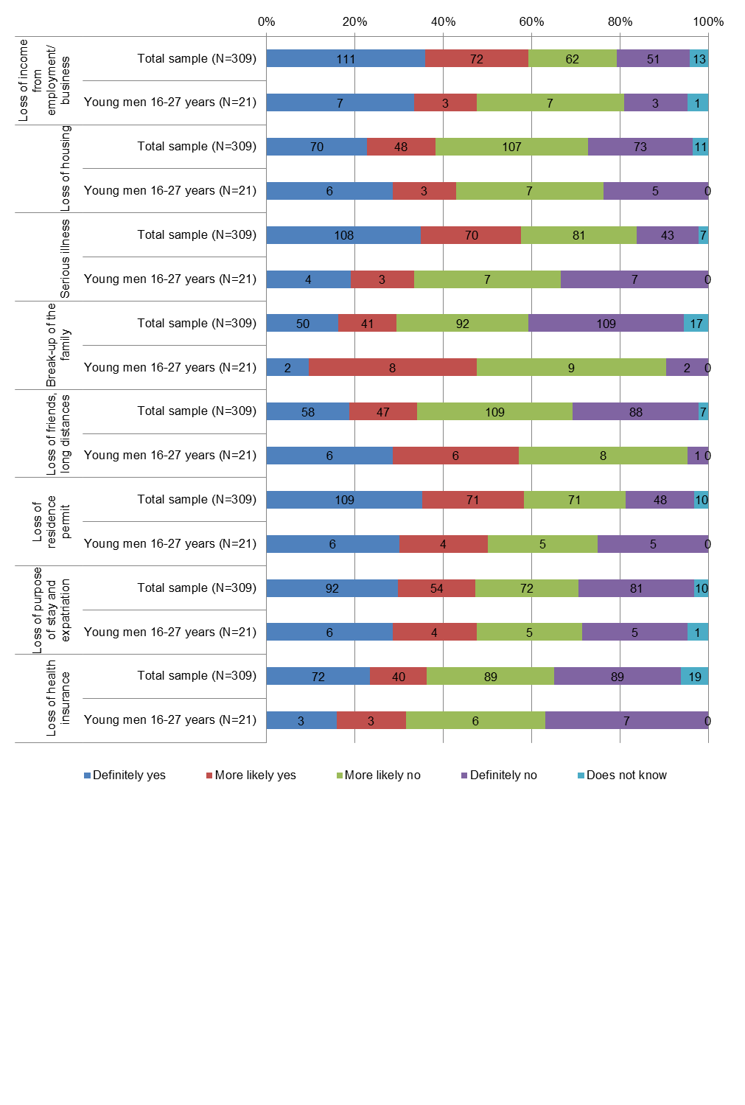

Source: Barriers of the integration from the perspective of Third Country Nationals (D. Schebelle, M. Horáková, 2012).

**Health insurance**

Young migrants - men were less interested in health insurance than older migrants. They were mostly insured in the CR, but less often than older migrants; three of them were insured abroad (in home country), two didn’t know if their employer pays their health insurance or not. They are young and they probably do not pay so much attention to health insurance as older migrants.

Foreigners without permanent residence are excluded from public health insurance in the CR; they can be insured by private insurance companies only, which do not cover all treatments (cases), especially expensive ones. This policy was criticized by the UN.

*Figure 24 Have you concluded health insurance?*



Source: Barriers of the integration from the perspective of Third Country Nationals (D. Schebelle, M. Horáková, 2012).

**Obstacles to integration**

Young migrants 16-27 years regard as the biggest barrier to their integration: missing interest in integration (3), Czech language (3), different look (2), strange name (2), loneliness, lack of friends, social contacts (3), unemployment (1), majority people (1), different way of life (1), bad conditions for business (no stone shop), other obstacles such as limited choice of phone tariffs (1). Three respondents have no obstacles to integration; one respondent believes that he is already integrated. Two respondents refused to be integrated in the CR.

**Information for migrants**

Actual information on important young migrant concerns is a good instrument for their integration. Eight young respondents know information brochures for migrants, thirteen not. Young migrants 16-27 years use information brochures less than other respondents. Only two from twenty one answered that these brochures helped them. Seven young migrants follow programmes for migrants in mass media. Nineteen respondents welcome initiatives of the CR government supporting migrants´ integration, as for example language courses, social and legal counselling, multicultural festival etc. and they believe that this activities support migrants integration.

***3.4 How do live migrants in Prague?***

Sociological research carried out among migrants living in Prague (ICP Praha, 2014) provides general information on satisfaction of foreigners in the capital, where share of foreigners - third country nationals in total population is about 10% (number of TCN as of end October 2013 was 110,000); 25% of sample of interviewed were from 20-29 years age group. The proportion of men by nationality ranges in the sample of respondents from 43% to 60%. Differences in share of men correlated to country of departure of foreigners. Foreigners are more satisfied with life in Prague than Prague inhabitants themselves. Three quarters are very or rather satisfied, whereas only 63% of Prague residents are satisfied. Satisfaction with life in Prague was related to achieved education of foreigners, to country of origin, and to interest in settlement. The most satisfied were citizens of Russian Federation (92%), other foreigners (80%) foreigners from countries of former Soviet Union (75%), Vietnamese (74%), and Ukrainians (68%). Satisfaction with life in Prague was linked to character of performed job and education of respondents. The interviewed sample contained 54% of university and 41 % of high school educated respondents, and this fact affected substantially results of the survey.

Migrants were most satisfied with standard of health care (73%), availability of health care (72%), availability of education (61%), functioning of municipalities (57%), availability of housing (56%), standard of education (54%), job (50%), relations between Czechs and migrants (48%), functioning of OAMP MV ČR (Department of asylum and migration policy of the Ministry of the Interior of the CR). The most positive assessment of different aspects of life in Prague was by Vietnamese, less satisfied were Russians (except for standard of housing). Satisfaction with life in Prague was in greatest extent influenced by knowledge of Czech (29%), good job (17%), good relations between Czechs and migrants (12%), equal chances in the labour market (11%), friendly links in the CR - not only with Czechs - (10%), orientation in CR institutions (9%), orientation in habits (7%), enough of Czech friends (4%).

Nearly one half of interviewed (46%) living in v Prague felt discrimination, and one third experienced racial or xenophobic behaviour. Racism from the Czech side was most frequently encountered by Vietnamese (46%), at the least by Russians (56 % of them never encountered racism from Czechs). Majority of interviewed, however, felt to be discriminated due to their migration origin. This was the answer of 66% of Ukrainians, 69% of Russians, 71% of migrants from former USSR countries, 55% of other foreigners, and only 33% of Vietnamese.

51% of migrants aged 15-19 and 42% of them aged 20-29 want to stay in the CR. They are primarily respondents with university education, mainly Ukrainians. On the contrary, Russians want to move (20%), but to another country; just 1% of university educated Russians consider returning to home country. University educated Vietnamese contemplate more often return to Vietnam.

Satisfaction with life is also related to employment of respondents, i.e. whether they have a job corresponding to their education and qualification. Full-time job have 37% of Ukrainians, 29% of migrants from former ??socialist countries, 24% ??.

**4. Portrayal of foreigners in the Czech media – young foreigners and foreigners in general**

The daily media (both printed and electronic) make public single events related to target group rather than to present broader picture of young foreigners’ life[25], reports or contextual information related to them. The latter approach appears in daily media only exceptionally and accidentally and it is applied rather by magazines, journals with week or higher periodicity, media which focus on specific audience (interested public, students, scholars etc.), public media (Czech TV and Czech Radio), media covering specific relevant topics (migration, ethnicity, demography, integration, employment, education etc.), media ran by NGOs (web portals, newsletters or brief reports - either regular or issued occasionally within specific information campaigns) or minority media.

This event-oriented approach leads media to consider young foreigners mostly as individuals. Some events also refer to groups of foreigners[26]. However, even reports with this focus are mostly limited to the description of individual events and particular reports are prevalently neither utilized for general characterization of young foreigners nor as an impetus to consider young foreigners a specific group.

Media are focusing on rather negative news (especially criminal cases; some important criminal cases are often pursued thoroughly and this intensifies the incidence of this matter as well – see below).

According to Anopress media articles database[27] half of all events relating to young foreigners which were covered in media regarded criminal cases, offences, conflicts of foreigners with majority etc. Reports with this content made three fifth of all reports about young foreigners, i.e. this type of events was covered (by the same or other media) more often than other types of events. The next important type of events/reports (around 15 per cent of both relevant events and reports) regarded cultural or art events and various actions with international attendance (exchanges, international work camps etc.). The proportion 5 to 10 percent from all relevant events/reports was registered in the case of events/reports concerning health or accidents, events/reports concerning education, courses or internships and events/reports on discrimination or assaults against foreigners. Other identified topics[28] were registered only rarely.

*Table 24 Number of news and events regarding young migrants in Czech media (1.1.2011 -10.3.2014)*

| Classification of events / news | Events | | News | | Average share of events/news |
| --- | --- | --- | --- | --- | --- |
| Number | % | Number | % |
| Criminal conduct (other than illegal stay or illegal job), violations, rowdyism, conflicts between foreigners and majority | 63 | 49 | 118 | 57 | 1.87 |
| Culture of other country, art, learning other cultures, exchange of experience | 20 | 16 | 26 | 13 | 1.30 |
| Health, illness, injuries, psychic health/problems | 11 | 9 | 16 | 8 | 1.45 |
| Study, requalification, courses, scholarships | 10 | 8 | 10 | 5 | 1.00 |
| Discrimination, xenophobia, attacks on foreigners, criminal conduct vis-à-vis foreigners | 7 | 5 | 8 | 4 | 1.14 |
| Death of a foreigner with no information about cause of death, corpse discovery, missing person, search published | 4 | 3 | 8 | 4 | 2.00 |
| Integration policies, measures, services, assumptions and integration possibilities | 4 | 3 | 7 | 3 | 1.75 |
| Illegal stay/work | 3 | 2 | 5 | 2 | 1.67 |
| Legal business, work | 3 | 2 | 3 | 1 | 1.00 |
| Ethnic conflicts, conflicts between conflicts | 2 | 2 | 5 | 2 | 2.50 |
| Sport | 2 | 2 | 2 | 1 | 1.00 |
| Assessed events/news total | 129 | 100 | 208 | 100 | 1.61 |

Source: Database of media articles received in Anopress media monitoring application (see [www.anopress.cz](http://www.anopress.cz)). Searched keywords: “young foreigners”, data extracted: 11 of March 2014. The whole database contained in total 331 articles matching the above keywords with estimated relevancy varying from 80 to 93 per cent. The further categorization was based on article summaries or article titles respectively. Included were only articles in which the summary or the title provided suitable information for categorization and only if foreigners were explicitly mentioned there (either in the summary or in the title). These conditions were met by 217 articles, but 9 therefrom referred to other countries and not to the situation in the Czech Republic.

To conclude there is no special focus on **young** **foreigners** in media. Media mostly cover other social phenomena as the topic of young foreigners is still not seen as important one (there are so far no notable social impacts, conflicts etc., and it is not perceived as crucial theme for Czech society in general). The media therefore report rather on foreigners in general or to specific communities according to citizenship or nationality (mostly Vietnamese and Ukrainians, which represent most numerous communities of TCN)[29].

Specific exception, however, is the case of young Vietnamese. Representatives of this visibly different minority migrated already to Czechoslovakia (mostly in 80’s, but Vietnamese migration started already in 60’s). Practically since the collapse of communist regime in 1989 the public attention was to some extent devoted also to second generation of Vietnamese. However, there is no clear distinction between focus on foreigners or ethnic minorities in media: Vietnamese from second generation should represent both Vietnamese and Czech citizens with Vietnam origin, but this fact is practically not recognized, neither in media discourse, nor by general audience. Reports on the second generation of Vietnamese therefore often mix these two different aspects together and are not always relevant for this project.

Media mostly reflect some characteristics of the second generation of Vietnamese which are discussed also in scholar debate, e.g. education (results above Czech average), behavior conforming to Czech society, comparison of the first and second generation (higher education and job expectations of the second generation, diverse attitudes to small and medium business between generations, etc.). Separate portrayal of the second generation of Vietnamese in media therefore should be seen as rather positive, but the image of young Vietnamese shapes definitely also general picture of Vietnamese in media, which covers also many stereotypical or explicitly negative characteristics of this community (e.g. partial distance between Czech and Vietnamese community / some trends to separation of both communities, suspicions or cases of tax evasion, selling of fake instead of original goods, illegal work or most recently criminal cases of drug production or distribution).

As regards other groups of foreigners, the focus on second generation or young foreigners is only exceptional. However the MiMen project target group should involve also other important groups of young foreigners. The most numerous group of relevant TCN are Ukrainians. They migrated to Czech Republic mostly for the work reasons and they often participate in low paid jobs (construction workers or cleaning women). Huge participation of Ukrainians in low paid jobs is reflected widely in media and also a simplified presentation of Ukrainians appears there often. The stereotypical image of Ukrainian men as (illegal, not regularly employed) construction worker is therefore widespread in the society, too.

Special attention is also devoted to Russians (especially in the regions with highest concentration of Russians, i.e. Karlovy Vary – Karlsbad or Prague), but there is no clear concentration on younger representatives of this community. Other groups of foreigners (according to their nationality) are not portrayed in a specific manner (neither in general, nor according to age).

**5. Scholar reflection of challenges encountered by young foreigners**

MiMen project target group (TCN men 16-27) was not yet subject of scholar debate as a specific target group. Therefore there is still neither scientific study specifically devoted to this target group, nor programs focusing specifically on this group of TCN.

The gender aspects of foreigners’ integration are reflected in many projects (both projects providing services to foreigners and research projects). However highlight on gender agenda in existing projects means either provision of special measures for women or specific adjustment of services provided to men and women according to specific needs of groups or individuals. Scholar debate on measures specifically focused on men practically has not started yet and there are actually only exceptional projects concentrating on migrating men[30].

There are also several projects, which focus specifically on selected age groups, especially on young foreigners. This concerns mostly projects focused on schooling or projects providing assistance to young people looking for a job. However as regards the reflection of age criteria, there are important differences between these two areas. Especially state institutions have diverse standpoint to the question, whether to differentiate target groups according to age: while educational institutions focus on young people primarily, for employment and labour market institutions it is important, whether client belongs to groups of people endangered at the labour market or not. Age should be treated in this regard as one of important criteria; however, young people in general do not belong mostly to endangered groups. Therefore young people in general have access mostly to universal (not specific) services or measures in the area of employment. At the same time, also the TCN in general are not treated as endangered group.

On the other hand NGOs should apply all possible approaches (i.e. not to consider the age criteria, target young people primarily, target them exclusively or offer them special services) both in the education area and in the area of employment.

For this project target group should be relevant projects or services which:

* target young people and are reasonable for TCN men as well, or
* are intended for all TCNs and are not stipulated exclusively for other TCNs than MiMen project target group.

However both these groups of projects/services should not necessarily develop special measures for young TCN men (or for broader group of young migrants). In practice, they are rather “only” accessible for them and do not specialize on them. Most important (and factually unique) organisation focusing exclusively on young migrants is NGO Meta which develops different projects for (a) young migrants both in the education area and area of employment and (b) for scholars working with this group. The organisation provides also general advisory and social work to young migrants and support to social workers[31]. Special focus on young migrants have also several projects run by International Organisation for Migration (IOM) and Association of citizens dealing with migrants (SOZE[32]), however both these organisations offer services to TCN in general (or focus on other groups of TCN) as well.. Other organisations do not specialize remarkably on young migrants. Basic characteristics of projects focusing especially on young migrants shows Annex.

As regards scientific reflection, some researches reflected sex and age criteria at the same time[33]. Nevertheless the project target group is very unusual in the Czech Republic and there are no comparable data. Moreover, specific researches among young migrants stress education, whereas other dimensions of peoples’ well-being are not investigated thoroughly. For this reason authors separated information on men aged 16-27 from two empirical surveys carried out in RILSA. Data in both these projects covered issues relevant to other dimensions of well-being as well (see above).

To sum up, many practical (services and measures for the target group) projects should involve young TCN men, but there are no specific projects for this group (neither for 16 - 27 age group, nor for different classification). The specific knowledge on young TCN men is missing completely. Research projects focused on broader target groups of TCNs should provide certain outline only if their findings were classified by gender and age. Relevancy of such findings is often limited, as they are gathered from different sources. The findings from these sources are sometimes also only partial and therefore it is practically impossible to compare them and get systematic and coherent knowledge of TCN men aged 16-27 years.

**6. Synthesis of relevant findings on selected challenges**

**Disadvantages**

On the basis of research materials we can state that especially young migrant with irregular stay and economic activities have problems. Problematic is that it is very easy to slip from regularity into irregularity, not only in the CR. Young men – migrants aged 16-27 legally staying in the CR have, according to sporadic data from our research, rather less problems than older migrant men. It is mainly because they are mostly not employed yet and often they are students. According to findings of our research they seem to be more adaptable than older men in many aspects, they also cope easier with the language barrier. Some young men with a migration history themselves see as a disadvantage the fact that they are foreigners, that they have a foreign accent or foreign name. Language and cultural divergence is perceived as a handicap by some of them, as well as look differing from majority population.

Vertical social mobility of young men with a migration history is most frequently blocked by lack of social capital. Their well-being can also be affected by their address. According to findings of PFUK foreigners accumulate in certain areas or regions, and that produces certain advantages and disadvantages.

Findings of research “Integration of children of foreigners from third countries” confirmed that study results of Czech children and children with a migration history were nearly equal[34]. Children from the former USSR countries, who arrived in the CR in the course of school age (54%) have worse results. About one fourth enters directly 2nd stage of basic school. They achieve the same study results like home populace in the foreign language.

Students with a migration history more often repeat study year (foreigners 9%: Czechs 3%) and in broader extent utilize tutor classes and extended classes of Czech, mathematics and natural sciences subjects. Every tenth respondent with a migration history attends tutor classes of the Czech language, whereas respondents from the former USSR countries twice as much (19 %); above all from the first generation of migrants (16 %), i.e. children born abroad. Children of foreigners use in higher rate options of extended classes of Czech and mathematics; in mathematics foreign respondents prevail over Czech classmates twice, and for foreigners from Asian countries the difference is even more pronounced (J. Vavrečková, K. Dobiášová 2012).

There are no findings about disadvantages in the vocational training of young migrant men in the CR. If there is some disadvantage of foreigners in the vocational training and in labour market in the CR, it concerns language barrier and lack of professional experience and contacts. MI provides information for schools and foreign students in Czech and English language at the address[35].

**Violence and delinquency of young men with immigrant background**

Statistical information on crimes of young migrants (16-27 years) is not available. Statistical survey of convicted foreigners by particular crimes in 2011 (see Foreigners in the CR CZSO 2012, p. 176-179) lists most often these: 112 larceny, 71 injury to health, 67 rowdyism, 66 endangering others under the influence of an addictive substance, 56 fraud, 46 credit fraud, 37 robbery, 33 embezzlement, 27 damaging another person´s property, 23 evasion of alimony payments, 19 violation of domestic freedom, 16 pandering, 9 violation against a group of citizens or an individual, 9 murder, 7 endangering the moral of juveniles, 3 trafficking in persons.

Most frequent convicted foreigners by Criminal Code section in 2012 were: 991 larceny; 867 endangering others under the influence of an addictive substance; 835 frustrating execution of an official decision; 243 evasion of alimony payments; 200 damage to property; 187 illegal production and use of other narcotics drugs and psychotropic substances and poisons; 167 injury to health; 159 unauthorised measures; counterfeiting and alteration of the payment; 156 violation of domestic freedom; 152 forging and altering a public document; 133 fraud; 107 robbery;

*Figure 25 Accused and convicted foreigners in custodial establishments and prisons 1998-2012*

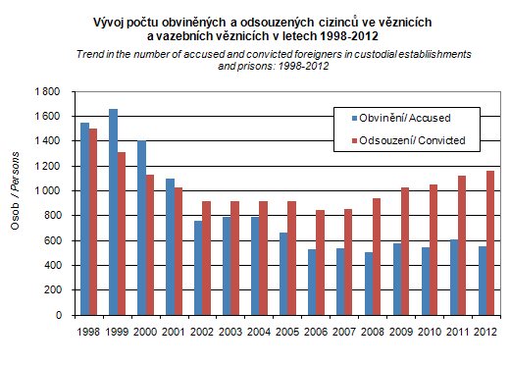

Source: CZSO.

**Radicalisation of young men with immigrant and Islamic background**

There are very few research findings about radicalisation of young men with migrant and Islamic background in the CR. The research results are mostly about general socio-pathology problems of migrants such as are trafficking, organized crime, racism and discrimination in employment. (Čižinský P., Dubová A., Hurrle J., Racism and related discriminatory practices in employment in the Czech Republic, Multicultural Center Prague, ENAR Shadow Report 2012-2013, 2014).

**7. Migration and integration policy of the Czech Republic**

**Public discourse on migration policy**

Public debate on migration policy covers general problems, such as:

* Should the CR government support foreign migrations, or not, and which form of migration should be supported?
* What are the security risks of foreign migration?
* Do foreigners take away jobs from home population (mainly in crisis time)?
* Is foreign migration benefit or loss for the CR (above all from economic point of view in connection with drawing social benefits by foreigners)?
* Do employers in the CR know how to utilize work potential of migrants, primarily their qualification (related to government programs facilitating migration of a qualified workforce)?
* Should government support settlement of foreigners?
* Should government support unification of families of foreigners?
* Should government extend social rights of migrants?

**Programs, policies, measures for the target group**

Responsible body for drafting of migration and asylum policy is the MI of the CR. Priority of migration policy is to support legally controlled migration and integration of long-term residing foreigners from third countries. The focus is on combating illegal migration.

Ministry of the Interior (MI) in cooperation with the Ministry of Labour and Social Affairs (MoLSA) and Ministry of Industry and Trade (MIT) designed and introduced specific migration policies in area of labour migration[36]. These policies were amended by the concept of support of circulation migration aimed at preventing the settlement of low-qualified workforce. Currently the CR government is abandoning these policies and it is replacing them with employee cards, which should be valid throughout the EU and which integrate work permit with residence permit.

Explicitly worded specific migration and integration **policies oriented towards young men with a migration history living in the Czech Republic do not exist so far. However, there are some, still rather unique, specific policies for young migrants, both men and women** (see Annex). At the same time, general integration policies naturally relate also to young men. Principle of equal treatment, which should be applied in all areas of social life, is usually explicitly focused on women, not men.

Policies for combating illegal migration refer to all, therefore to young migrants too. E.g. measures implemented prior to entry of a foreigner in the CR territory (strengthening awareness of foreigners, checking procedure in connection with granting visa), procedures aiming at disclosing irregular migrants at the border (API data or lists of passengers respectively, checks at plane exit), during their stay in the CR territory (residence checks) and options which the Czech migration policy offers to irregular migrants to solve their situation (visa to allow exceptional leave to remain, subsidiary protection, assisted voluntary returns) (MI 2012).

Specific policies concentrating exclusively on young men aged 16-27 years were not introduced in the CR so far. The reason is that latent problems of this group of migrants are perceived rather by experts and field workers than by politicians themselves. Problems of young migrants have not been discussed in the CR so far, because they are not manifested as problems of young, but as general problems of social pathology (crime, drug abuse, alcoholism, prostitution, trafficking in people, smuggling, etc.).

**8. Conclusions**

**Challenges**

**The knowledge of the situation of young TCN migrants 16-27 years in the Czech Republic is still rather limited.** However several research projects and secondary analysis of data from relevant research project conducted by authors showed that **main problems** of young TCN migrants 16-27 years in the Czech Republic **are as follows**: to keep legal residence status especially of temporary migrants, acquiring of Czech citizenship; low participation in social networks and low social capital; discrimination, especially in employment, above all wage discrimination; difficulties faced by ethnic minorities and migrants in accessing the labour market and progressing in employment, and difficulties in using professional qualification.

Young men with a migration history need a stable residence for successful integration; permanent residence permit can be after 5 years of uninterrupted stay in the CR at the earliest, and there is no legal claim for permanent residence permit; the CR granted rather low number of state citizenships. Since 1st January 2014 it is easier for foreigners to acquire the CR citizenship. Access of young migrants to the labour market is complicated not only by systemic measures (introduced in order to protect labour market), but also by economic crisis. Interest in political social or participation of young migrants is very low. According to Bulletin for State administration/Bulletin pro státní správu, 31.1.2012 the main barriers of political participation are as follows: “disinterest of state and majority in their opinion, their real inclusion into society, and also anxiety and mistrust of foreigners themselves **vis-à-vis state and majority”.**

**Portrayal**

**The group of young TCN men and their situation are however still neither differentiated nor treated as important matters.** This fact concerns public debate and media as well as scholar debate, vast majority of research projects and also the majority of migration and integration policies. The reasons of low attention to the target group differ across all these areas; however it could be notably influenced by several facts such as:

* The public debate concerns mostly on effects of migration on the Czech society, not on its effects on different group of migrants;
* Strong tensions and clashes between young migrant men and host society are still factually absent or they are to a large extent latent;
* Both the public debate and existing measures concern mostly actual situation and problems; no or minimal attention is devoted to future expectation or development trends;
* Young migrants are often able to adapt easier to new situations and to requirements of society than older ones (as documented in the analysis above);
* The position of women is emphasized in the case that the gender issue is reflected.

**Policies**

Though the MiMen project target group is not generally seen as essential for the success of integration policy, there are already **organisations** (IOM, Meta, SOZE) which **reflect the importance of young migrants (both men and women) for the integration process** and which run some (rather rare) specific projects for them.

However **young migrant men are predominantly treated similarly as other groups of TCN** (and in some policies similarly as all other inhabitants in respective situation) according to non-discrimination principle. An illustrative example is the situation of young migrants who register at labour offices as job seekers. Young TCN men (as well as TCN in general) are not automatically recognized as vulnerable group in the labour market (i. e. people who have access to wider range of services offered by the labour offices). However some young migrants should “fall” in categories recognized as vulnerable groups because of some other characteristics. In this case they fulfill requirements which entitle them to benefit from wider range of services of the labour offices. Unfortunately young migrants only rarely use services of the labour offices (Rákoczyová, Trbola 2014).

For this reason, the assessment of existing policies for young TCN men should not reflect only “marginal nature” of specific programs for young TCN in comparison with general migration and integration policies (and factual absence of special programs for young TCN men). It should consider at least two above mentioned important facts: First, the majority of migration and integration policies is open also for young TCN men. Second, the situation of young migrants (both men and women) is not seen yet as a problem by wide public, or policy makers respectively. However important is that specialists on foreigners´ integration and field workers reflect this potential problem of young migrant men.

**References**

Metodika pro tvorbu informačního systému o rodinách imigrantů z třetích zemí / Constitution of the Information System on Families of Third Country Nationals: Methodics for Collection and Application of Relevant Data. Horáková M., Bareš P., Schebelle, D., Kubát, J. Uherek, Z., Brouček, S., Beranská, V. Výzkumný ústav práce a sociálních věcí, v.v.i., Etnologický ústav AV CR, v.v.i., 2014. <http://www.vupsv.cz/index.php?p=project_publications&projekt=209&site=default>

Jak se žije migrantům a migrantkám na území hl.m. Prahy/ How do live migrants in Prague? ICP (Integrační centrum Praha, o.p.s., Praha, 2014

Racism and related discriminatory practices in employment in the Czech Republic. Čižinský, P., Dubová, A., Hurrle, J., Multicultural Center Prague, 2013.

Bulletin pro státní správu/Bulletin for State Administration, 31.12. 2012. <http://migration4media.net/wp-content/uploads/2012/02/Bulletin-V-obraze-2012.pdf>

Cizinci v České republice / Foreigners in the Czech Republic, website of Ministry of Labour and Social Affairs (MoLSA ) <http://www.cizinci.cz/news.php?lg=1>, 13.3.2014

CZSO. <http://www.czso.cz/csu/cizinci.nsf/engkapitola/ciz_nabyvani_obcanstvi>, 14.3.2014

2011 Population and Housing Census, Czech Statistical Office (CZSO). <http://www.czech.cz/en/Discover-CZ/Facts-about-the-Czech-Republic/Geography/Population-census-in-the-Czech-Republic-–-foreigne>, 10.3.2014.

Cizinci v České republice, ČSÚ/Foreigners in the Czech Republic 2012. Czech Statistical Office; ISBN 978-80-250-2039-5.

Cizinci v české republice/Foreigners in the Czech Republic, ČSÚ 2013, ISBN 978-80-2580-2439-3.

Rákoczyová, M., Trbola, R. Zkušenosti cizinců se službami úřadu práce vybraného regionu v době ekonomické krize / Experience of foreigners with labour office services in selected region during economic crisis. Fórum sociální politiky, 1/2014, pp 9-16.

D. Schebelle, M. Horáková: Bariéry integračního procesu reflexí cizinců ze třetích zemí/Barriers of the Integration from the Perspective of Third Country Nationals. RILSA 2012. ISBN 978-80-7416-112-4.

M. Horáková: Vývoj pracovních migrací v České republice v období hospodářské recese, RILSA 2010. ISBN 978-80-7416-069-1.

Zákon č. 186/2013 Sb., o státním občanství České republiky/Act No. 186/2013 Coll., On State Citizenship of the Czech Republic.

Y. Leontieva, M. Vávra, Postoje K migrantům / Attitudes towards migrants. Sociologický ústav Akademie věd CR, v.v.i., Praha 2011. ISBN 978-80-7330-199-6.

M. Bartoš: Postoje majority v České republice k migrantům v průběhu let 2002 - 2008. Sekundární analýza. / Attitudes of majority towards migrants during 2002-2008, secondary analysis. Masarykova universita v Brně. Bakalářská práce 2010.

Immigration to the Czech Republic and Families of Foreigners. [Imigrace do České republiky a rodiny cizinců.]. / Milada Horáková, Zdeněk Uherek, Tereza Pojarová, Zuzana Korecká - In: On some migration and development issues : Collection of papers presented at the conference "Migration and development" / Jiří Novosák. - Ostrava : University of Ostrava, Department of Human Geography and Regional Development, 2008. - ISBN 978-80-7368-442-6. - s. 180-189.

Integrační funkce rodiny v procesu migrace. Hlavní zjištění projektu Interface. [The integrational function of the family in the migration process. Principal findings of the Interface project.]. / Milada Horáková, Pavel Bareš - In: FÓRUM sociální politiky. - ISSN 1802-5854 - Roč. 3. č. 5 (2009), s. 8-16 (9 s.).

The Immigrant Family in the Integration Process [Rodina imigrantů v integračním procesu]. / Pavel Bareš, Milada Horáková - In: Migration, Diversity and Their Management. - Praha: Institute of Ethnology, Academy of Sciences of the Czech Republic, v.v.i., 2011. - ISBN 978-80-87112-46-5. - s.103-132 (30 s.).

Project “Inter-face“: Immigrants and National Integration Strategies - Trans-European Framework for Analysing Cultural and Employment Related Integration. 2006-2008. Founded by the European Commission, DG Justice and Home Affairs in the INTI-Programme.

Dion, Keneth L. (2001): The Social Psychology of Percieved Prejudice and Discrimination, University of Toronto, p. 10

J. Vavrečková, K. Dobiášová: Integrace dětí cizinců z třetích zemí na základě mezinárodního šetření OECD PISA a řízených rozhovorů s pedagogy základních škol, VUPSV, v.v.i. 2012

National Contact Point of the European Migration Network in the Czech Republic. EMN Study Practical Measures for Reducing Irregular Migration in the Czech Republic. Studie EMN o opatřeních směřujících k omezování neregulérní migrace v ČR, MI, 2012.

T. Kušniráková, P. Čižinský. Dvacet let české migrační politiky: liberální, restriktivní, anebo ještě jiná? / Twenty Years of Czech Migration Policy: Liberal, Restrictive or Something Different? Geografie, 116, No. 4, pp. 497–517. – Geografie, 2011. No 4, Vol. 116. Pp. 497-517.

Integrační centrum Praha/Integration Centre of Prague (ICP). Jak se žije migrantům a migrantkám na území hl.m. Prahy. Závěrečná zpráva z dotazníkového šetření. / How do live migrants in the capitol Prague? Final conclusions of sociological survey.

Metodika využívání poznatků o rodinách imigrantů při zjišťování potenciálních nároků sociálního systému, které jsou spojené se slučováním rodin. ): Bareš, P., Horáková, M., Schebelle, D., Kubát, J., Uherek, Z., Brouček, S., Beranská, V., / Metodology of gathering knowledge on migrant families. Its utilization in the assessment of potential demands of family reunuion on social systems, Výzkumný ústav práce a sociálních věcí, v.v.i., Etnologický ústav AV ČR, v.v.i. , 2014.

J. Holas: Politický radikalismus a mládež, / The current situation in the field of extremist movements in the Czech Republic with an emphasis on their potential support among young people and the spread of extremist ideological content over the Internet. ISBN 97880-7338-131-8. Institut pro kriminologii a sociální prevenci, Praha. ISBN 978-80-7338-13

Čižinský P., Dubová A., Hurrle J., Racism and related discriminatory practices in employment in the Czech Republic, Multicultural Center Prague, ENAR Shadow Report 2012-2013, 2014

van Balen B., Barry U., Holzhacker R., Villagomez E., Wladasch K. Part II - Ethnic Minorities, Migrants and Employment, Network of socio-economic experts in the non-discrimination field VT-2008-007, Synthesis report 2010.

Cizinci z třetích zemí se zaevidovaným povoleným pobytem na území České republiky a cizinci zemí EU + Islandu, Norska, Švýcarska a Lichtenštejnska se zaevidovaným pobytem na území České republiky k 31.12. 2013. [www.mvcr.cz](http://www.mvcr.cz)

**Annex**

**Policies and projects oriented towards young migrants**

**1. Governmental policy**

1.1. Ministry of the Interior designs government foreigners’ integration policy and delegates its implementation to integration centres and NGOs dealing with foreigners, finances their activities and controls their effectiveness. Refugee Facilities Administration of the Ministry of the Interior (RFA) opened Centres for Support of the Integration of Foreigners (CPIC). CPIC were established within the framework of projects financed by the European Fund for Integration of Third Country Nationals. We did not find any specific project for young migrant-men aged 16-27 years.

1.2. State policy focused at removing language barriers of children of foreigners was started on 1st January 2012, when an amendment to the new School act No. 472/2011 Coll., applying also to education of foreigners came in force. Regional governments together with founders of elementary schools (according to place of residence of a student) are obliged to ensure to foreigners with obligatory school attendance a free teaching of the Czech language corresponding to their needs and knowledge.

1.3. Ministry for Labour and Social Affairs (MoLSA) establishes active employment policy, which is applicable to permanently residing TCN, regardless of their age and sex. MoLSA also publishes information for foreigners living in the CR. It aims to help foreigners coming primarily from non-EU countries “to get better understanding of common life situations, which they may encounter within the process of integration into the Czech society. Apart from the basic information on the Czech Republic, the publication informs about the structure and functioning of the public administration dealing with emergency situations, education system, healthcare and social security, employment, residence, transport and other issues. Moreover, it should serve as a comprehensive and practical guide, which refers to more detailed information sources in case of further interest in a given field. The information contained in the publication refers to conditions applicable from 1st January 2011 if not stated otherwise”. The MoLSA series of information publications for foreigners contains the following titles: 1) Are you a foreigner doing business in the Czech Republic? 2) The information for foreigners with a for long-term residence permit. 3) Are you a foreigner who wishes to extend the validity of your work permit or who has just lost your job? 4) Housing in the Czech Republic - information brochure for foreigners. (<http://www.mpsv.cz/en/>)

1. *Support area 3.1 Support of social integration and social services of OP LZZ (Operational Programme Human Resources and Employment)*

Through Support area 3.1 (see above) above all activities and actions are supported which enable prevention of social exclusion or direct assistance with emphasis primarily on:

* programmes of prevention of socially pathological events including crime prevention
* programmes of acquiring basic social and professional skills,
* programmes of financial literacy for persons jeopardized by indebtedness (including consultancy),
* programmes oriented on teaching Czech, should the language be a barrier to access or maintaining position in the labour market.

In 2013 projects from Support area 3.1 were implemented, which focused on immigrants and asylum seekers, awarded in previous calls for proposals 30, 43, 67 in the past. Projects from calls 30 and 43 were concluded, projects from calls 67 were in implementation phase

|  |  |  |  |  |
| --- | --- | --- | --- | --- |
| Project title | Awarded to | Total cost (CZK mil) | Project start | Project finish |
| You have a chance to participate! | Evropská kontaktní skupina | 6.886 | 01.07.2011 | 30.04.2014 |
| Common city - project of training foreigners in basic social and work knowledge and skills | "Občanské sdružení Téma dne" | 1.207 | 01.08.2011 | 30.06.2014 |

Two projects from the 86 call started implementation:

CZ.1.04/3.1.02/86.00156 „On the way to work“

Goal of the project is to remove barriers for foreigners in integration and equal participation on the labour market in Plzen and Central Bohemia regions.

CZ.1.04/3.1.02/86.00204 „Legal and qualified work for foreigners in the Central Bohemia region“

Goal of the project is to assist foreigners to find their place in the labour market.

|  |  |  |  |  |
| --- | --- | --- | --- | --- |
| Project title | Awarded to | Total cost (CZK mil) | Project start | Project finish |
| On the way to work | Evropská kontaktní skupina | 5.528 | 01.02.2013 | 30.06.2015 |
| Legal and qualified work for foreigners in Central Bohemia region | Poradna pro integraci, občanské sdružení | 4.699 | 01.01.2013 | 30.06.2015 |

In May 2013 a call was published in Support area 3.1 “Support of social integration and social services”, which was focused on social innovations; proposals were submitted by end of 2013. In framework of this call also activities oriented towards support of asylum seekers and migrants may be supported.

Activities planned for 2014:

In 2014 no other calls are planned

1. *Support area* *3.3 “Integration of socially excluded groups into labour market”* of OP LZZ

In the Support area 3.3 of OP LZZ *“*Integration of socially excluded groups into labour market” projects selected in calls 75 and 96 were implemented in 2013.

The above calls are focusing on a spectre of target groups endangered by social exclusion, one of them beiing also „asylum seekers and immigrants“.

Projects from OP LZZ Support area 3.3 are grant projects with maximum duration 2 years and maximum support CZK 6 million. They can be either regional or supra-regional (focusing on more regions) and can be implemented in all regions of the CR with exception of Prague.

In 2013 projects focusing on asylum seekers and immigrants from Support area 3.3 were implemented in framework of calls 56, 68, 75 and a new call 96. Projects from calls 56 and 68 were terminated during 2013 (European contact group in the Czech Republic, Burma Center Prague, o.p.s. and GLE o.p.s.); projects from call 75 continued implementation:

CZ.1.04/3.3.05/75.00005 „Support and integration of Vietnamese immigrants in the labour market via occupational training“

Grant recipient plans to involve in the project target group of Vietnamese immigrants aged less than 25 years with low/no qualification.

CZ.1.04/3.3.05/75.00091 „Support and assertion of foreigners in craft vocations in the Ústí nad Labem region“

Project is focusing on support of target group of asylum seekers and migrants – TCN foreigners living in the Ústí nad Labem region and jeopardized by social exclusion or socially excluded.

CZ.1.04/3.3.05/75.00160 „We start anew!“

Project tries to react to current needs of foreigners who were awarded asylum or and additional protection in the CR according to the asylum act.

CZ.1.04/3.3.05/75.00082 „Integration of foreigners into labour market in the South Bohemia region“

Project is focusing on a comprehensive support to a target group of asylum seekers and immigrants in a form of a training programme, which will consist of not only an intensive course of Czech for foreigners, but also of information (law, finance) necessary for concluding work contract and residence in the CR in general.

|  |  |  |  |  |  |
| --- | --- | --- | --- | --- | --- |
| Project title | Awarded to | Total cost (CZK mil) | Project start | Project finish | |
| Support and integration of Vietnamese immigrants in the labour market via occupational training | KLUB HANOI | 3.073 | 01.07.2012 | 30.6.2014 |
| Support and assertion of foreigners in craft vocations in Ústí nad Labem region | Poradna pro integraci, občanské sdružení | 5.015 | 01.05.2012 | 30.4.2014 |
| We start anew! | Organizace pro pomoc uprchlíkům, o.s. (+ Masarykova univerzita) | 4.716 | 01.06.2012 | 31.05.2014 |
| Integration of foreigners into labour market in South Bohemia region | ERUDICO s.r.o. | 5.854 | 01.10.2012 | 31.05.2013 |

In 2013 the following projects selected in call 96 started implementation:

CZ.1.04/3.3.05/96.00060 „Creation of broader network of Czech-Vietnamese assistants in the Karlovy Vary region“

Objective of the project is implementation of the programme for the target group of young Vietnamese. CZ.1.04/3.3.05/96.00123 „To succeed without obstacles“.

The goal of the project is to provide 40 applicants for award of international protection an individual assistance in preparation for entering the labour market.

CZ.1.04/3.3.05/96 „Education=chance to work! Support to disadvantaged foreigners in entering the labour market in the Ústí nad Labem region“

The goal of the project is to ensure provision of comprehensive, mutually interrelated consultancy, educational and assistance services for the target group of foreigners from the Ústí nad Labem region, which consists primarily of foreigners with long-term residence in the CR.

|  |  |  |  |  |
| --- | --- | --- | --- | --- |
| Project title | Awarded to | Total cost (CZK mil) | Project start | Project finish |
| Creation of broader network of Czech-Vietnamese assistants in the Karlovy Vary region | KLUB HANOI | 3.134 | 01.04.2013 | 31.10.2014 |
| To succeed without obstacles | Organizace pro pomoc uprchlíkům, o.s. | 5.674 | 15.04.2013 | 14.04.2015 |
| Education=chance to work! Support to disadvantaged foreigners in entering the labour market in the Ústí nad Labem region | Contact Line, o.p.s. | 3.359 | 15.03.2013 | 14.09.2014 |

Activities planned for 2014:

In 2014 implementation will go on of majority of projects from the calls nos75 and 96, projects from the call no. 68 will be approaching their termination. No other calls are planned.

1. *Support area 5.1. International cooperation*

Within the framework of this priority axis activities are financed focusing on support of international cooperation between projects in various member states, among groups of stakeholders oriented towards specific areas, actors from common regional area with actors from other areas, and between national organizations in several member states. Support to the target group of immigrants and asylum seekers are not a primary goal in this area; however, several applicants active in the field of migration used the opportunity to incorporate international cooperation into their projects. Because it is primarily in the form of partnership, we also state names of foreign partners for particular projects.

In the past, projects from calls 12 and 51 were finished in 2013.

We are presenting projects supported in the framework of the 3rd round of the call 77. Implementation of these projects commenced in November 2012 and their duration will be ca 2 years.

CZ.1.04/5.1.01/77.00336 „Foreign experience with integration of foreigners in the labour market automotive industry “

The project aims at improving situation in integration of foreigners in the labour market, mainly at employers in automotive industry, which are employing foreigners, through transfer of experience and good practice from the German partner.

CZ.1.04/5.1.01/77.00344 „Integration of foreigners in the labour market“

Central goal of the project, which is implemented by EDUCTUS CZ, spol. s r.o., is to improve existing CR possibilities and approaches how to involve migrants and asylum seekers in the labour market, using transfer of proven experience from abroad. CZ.1.04/5.1.01/77.00416 „Formation of a profession "socio-cultural mediator"

Major focus of the project is to establish and develop a thematic network consisting of the foreign Portuguese partner, Czech NGOs working with migrants, Association of mediators, and Department of asylum and migration policy of the Ministry of the Interior CR (responsible for national integration policy of foreigners), the Ministry of Labour and Social Affairs CR – department of employment of foreign employment, and CARITAS – Higher professional social school in Olomouc.

|  |  |  |  |  |  |
| --- | --- | --- | --- | --- | --- |
| Project title | Awarded to | Partners | Total cost (CZK mil) | Project start | Project finish |
| Integration of foreigners in the labour market in the CR: role of Czech towns | Multikulturní centrum Praha | Centre Bruxellois d'Action Interculturelle asbl - CBAI; Humanity in Action Deutschland e.V.; Landeshauptstadt Dresden, Integrations - und Ausländerbeauftragte; Rejs e.V. | 8.292 | 01.05.2012 | 30.04.2015 |
| Paris suburbs are warning | Poradna pro občanství/Občanská a lidská práva | Dana Krejčí; SOS Racismo - Mugak; Verband fur interkulturelle Arbeit (VIA) | 9.231 | 01.04.2012 | 31.03.2014 |
| School of the second chance | Educa International, o.p.s. | Hagagymnasiet; Komvux; Naringslivskontoret; Středočeský kraj | 5.378 | 01.07.2012 | 30.06.2015 |
| Foreign employees in the labour market | SDRUŽENÍ PRO INTEGRACI A MIGRACI | Anti - Slavery International; Caritasverband für die Diezöse Osnabrück; Multikulturní centrum Praha; Organizace pro pomoc uprchlíkům, o.s. | 7.358 | 01.10.2012 | 30.09.2014 |
| Utilization of a potential and qualification of immigrants in the Czech labour market | Multikulturní centrum Praha | COSPE - Co-operation for the Development of Emerging Countries; ebb - Entwicklungsgesellschaft für berufliche Bildung mbH; Österreichischer Integrationsfonds | 5.928 | 01.12.2012 | 30.11.2014 |
| Integration of foreigners in the labour market | EDUCTUS CZ, spol.  s r.o. | ACIDI - Alto Comissariado para a Imigraçao e Diálogo; Asociace nestátních neziskových organizací Jihomoravského kraje; Úrad práce, sociálnych vecí a rodiny Senica; Úřad práce České republiky | 3.712 | 01.12.2012 | 30.11.2014 |
| Formation of a profession "socio-cultural mediator – inspired by the Portuguese model | InBáze, o.s. | ACIDI, I.P. Alto Comissariado para a Imigraçao e Diálogo Intercultural | 7.139 | 01.12.2012 | 30.11.2014 |

Activities planned for 2014:

In 2014 implementation will go on of majority of projects from the call no. 77. No other calls are planned.

**2. Association of citizens dealing with migrants/Sdružení občanů zabývajících se migranty (SOZE)**

SOZE was established in 1992 as non-governmental and non-profit organisation. Its main goal is to support integration of migrants and asylum seekers. It provides to migrants unpaid legal counselling, social and psychological counselling, it organizes leisure activities and education programs for migrants with a goal to support their effective integration into mainstream society and prevent social exclusion of migrants.

2.1. New project “Young migrants in need” is running since September 2013 and is targeted at disadvantaged young migrants from 17-25 years with any type of residence permit including undocumented migrants, both TCN and UE citizens residing in the territory of the Czech Republic. Project covers the whole territory of the CR, with majority of activities carried out in the Moravian regions. It includes social coaching (intensive individual social work), intensive language courses for all young migrants till 25 years with orientation on work language, tutorial lectures for school children, requalification for young migrants, supported work places “on approval” to prevent shadow economy or criminality of young migrants, housing up to three months in asylum center to prevent homelessness, and support of voluntary reintegration of young migrants to homeland including facilities and material aid in homeland in cases, when the stay of a foreigner is not maintainable according to the law. Voluntary returns and reintegration cover the whole territory of the Czech Republic. SOZE cooperates in the field of voluntary returns with International Organization for Migration. The project will finish in August 2015.

Disadvantaged young migrants are described in the project as follows: “This group of people is often marginalized and faces several additional barriers to enter regular labour market. These include inadequate knowledge of the Czech language, insufficient understanding of the Czech society, disregard to cultural norms and values, lack of knowledge of legal norms and legal system as such, which constitutes a barrier in orientation in their own rights. Because of their young age, they are especially vulnerable; they do face huge problems in securing sufficient financial income and thus become easily victims of crime, labour exploitation, trafficking, enslavement, debt entrapment and social exclusion in general. Further, migrants from new EU member states in Eastern Europe are favorite victims of traffickers for labour exploitation, recently due to their right to free movement and free residence after tightening the rules for employment of foreigners from third countries in the course of the economic crises”. <http://soze.cz/velux/?p=35&lang=en>.

**3. International Organization for Migration projects**

International Organization for Migration (IOM) is the leading inter-governmental organization in the field of migration and works closely with governmental, intergovernmental and non-governmental partners. Cooperation agreement between IOM and the Czech Republic was signed on 15 October 1997 in Prague. The agreement entered into force on 1st of November 1998. <http://iom.ecn.cz/english/about-iom.shtml>

3.1. Models for integration and prevention of exclusion: strengthening migrant youth

European project iYouth ran in 2012-2013 and aimed at empower migrant youth organisations dealing with integration and prevention of social exclusion of young migrants. Project had three main goals: 1) to develop models and training materials on integration and prevention of exclusion of young migrants; 2) capacity building of migrant youth organisations and to strengthen networks between them; to promote cooperation between youth organisations, regional offices, local offices, schools, pedagogues, leisure clubs, low-threshold treatment facilities and individuals working with young migrants; 3) awareness raising and dissemination of results. Peer review groups of participants evaluated policies and practices of NGOs and institutional environment in all partners’ countries. The training platform was established on the address: www.iyouth-project.eu.

3.2. Re-Turn project

Re-turn project ran during 2004-2007. Re-Turn’s main activities were linked to development and implementation of services needed to support migrants in their wish to return. Main outputs of Re-turn project helped to achieve sustainable services and supported structures to promote return migration (online-tool presenting regional and national remigration trends, handbook with transnational management tools to promote return migration, long-term implemented monitoring tools and support services for return migration). Based on Re-Turn project, participating regions strengthened their competitiveness and supported their cohesion. Decision-makers changed policy documents and working procedures in participating regions to improve knowledge of returning migrants.

3.3. Active Citizenship: Enhancing political participation of migrant youth (ACCESS)

The ACCESS project aims at enhancing migrant youth to become politically active citizens on local, national and EU-wide levels, thus to be able to better contribute to the formulation of policies. Through peer reviews of policies and practices in ACCESS project countries, the project provides concrete advice and tools to policy-makers how to include ideas and concerns of young people into decision-making.

In the context of this project, political participation of youth does not only includes participation in electoral processes but consists of a more comprehensive approach engaging all young people in the development, implementation and evaluation of all policies which affect them. Active political participation may entail taking part in e.g. local municipalities’ youth parliaments, lobbying, providing feedback to decision-makers and voluntary involvement such as neighbourhood committees and associations. The project aims to promote full participation and the social inclusion of young people by: 1) Capacity building of migrant youth on political participation. The activities will empower and enable youth to gain knowledge and skills as well as to build networks in order to foster their and their peers’ active citizenship, political participation and European identity within and beyond the project;   
2) Strengthening municipalities to work towards more profound involvement of migrant youth. This will provide opportunities for municipalities to assess and improve their policies and practices involving all youth in decision-making processes on local level, which is usually the most accessible level of engagement; 3) Awareness raising and building of networks. Building on the above activities and their outcomes, the project will raise awareness on the importance of political participation and active citizenship of migrant youth among relevant stakeholders and public in general.

**4. META Organisation**

Association for the Opportunities of Young Migrants (META) was established in 2004 with the aim to support young immigrants living in the Czech Republic. The clients of the association are young foreigners between the ages of 6 and 39 - regardless of their legal status. META was registered as a civic association by the Ministry of the Interior in December 2004. META supports the personal development of young migrants in the area of education, which is one of the preconditions for successful integration into the community. META also supports professionals dealing with education of foreigners.

Since 2006 the Consultancy and Information Centre for Young Migrants (PIC) is in operation. It is the core activity of META. Social workers consult and assist clients in the area of further studies, job opportunities, and tackling difficulties arising from their specific social and legal status in the Czech Republic. Part of the social consultancy service is the opportunity to get assistance from a volunteer who can help clients to achieve their goals – mostly in the form of tutoring and assistance in exam preparation. In addition to professional social consultancy and various educational activities provided under the volunteer program META also offer Czech language courses lead by experienced teachers, and preparatory courses for admission exams. In PIC the clients can also make use of a study room with a library, and a PC with internet connection. (<http://www.meta-os.cz/>)

Examples of META projects for young migrants (http://www.meta-os.cz/)

4.1 “Program for teachers working with pupils of foreign origin IV” (July 2012 – June 2013). The aim of the project was to build and improve the competences of state employees (teachers in the field of teaching pupils of foreign origin and the employees of county councils) by complex methodological and information support in order to streamline the integration of pupils from third countries into the Czech educational system;

4.2 “Comprehensive support to migrants in the field of education and employment” (July 2012 – June 2013). Counselling and assistance both in office and field were supplemented by courses of Czech language for foreigners. Czech language courses were amended by the support of volunteers in the form of tutorial classes. Volunteers support pupils who had problems with different subjects due to their language barrier. Advanced pupils had specialized grammar working groups. Volunteer support was accessible also for adult applicants to deepen a special professional terminology in Czech in order to succeed in the labour market;

4.3 To school with META” (January 2011 – December 2012). The project was focused on the support of education of socially disadvantaged pupils with foreign background at elementary and secondary Prague schools. Pupils were supported by social counselling, individual tutoring and leisure activities;

4.4 “Volunteers in META” (January 2011 – December 2012). Project was financed from the Ministry of Interior (voluntary service). It focused on implementation and further development of META voluntary programme. Volunteers were helping clients with their educational problems arising from their social and legal position and lack of information on the Czech educational system. Volunteers helped clients by tutoring them so that they could meet their study obligations, provided them with assistance if needed, and organized their leisure activities;

4.5 Project “Work, that’s integration!” (January 2011 – June 2012). The aim of the project was to prepare a comprehensive project application for the European Social Fund project. The project was focused on integration of people disadvantaged in the labour market. The target group of this project were foreigners who were discriminated against in the labour market due to their origin, residency status and insufficient knowledge of the Czech language. A thorough analysis of needs of the target group was carried out in cooperation with potential employers;

4.6 META in cooperation with Sociological Institute of Academy of Sciences of the CR organized a discussion on mixed marriages;

4.7 META introduced a free theatrical circle for basic school pupils and high school students. The circle was intended both for Czechs and foreigners and it was concluded by an auctorial performance originated under guidance of theatre professionals;

4.8 Journalistic and literary contest for elementary and secondary school students titled Czech is also my language;

4.9 Portal www.inkluzivniskola.cz, provides advice how to proceed in incorporating new pupils, and also practical tips, guidelines, working sheets, activities, contacts and many other useful information;

4.10 Project „Social interpreting in contact with foreigners” was implemented in the framework of public tender issued by the MoLSA CR. The goal of the project was to create an educational module and training of potential social interpreters from Vietnamese, Mongolian and Russian communities, their training and subsequent of professional internship;

1. Terms “immigration” and “immigrants” refer to people who have changed the place and country of their permanent residence. They imply settlement in a new, host country. Terms “international migration” and “migrants” have a wider meaning. They refer to both immigration and emigration and relate to international border crossing (the only difference is in the direction of the migration movement). They cover other types of migration movements, such as return, seasonal, border, transit or circulated migrations. Network of socio-economic experts on migrant employment in the EU introduced following definitions of target group; Eight reports mention that there is no definition of migrants used in their countries. In nine countries the use of the term ‘foreigner’ or ‘alien’ is common for referring to non-nationals. In three countries a ‘migrant’ is defined as a person born abroad with parents born abroad. Nationality and birthplace are used several times as an indicator for data collection. Second generation migrants are defined by the birthplace of one or both parents. In the Netherlands a distinction is made between western and non-western migrants. In two cases (Italy and Greece) the jus sanguinis rule is still followed, which means that only those people whose parents are Italian or Greek are seen as nationals, although there is the possibility for migrants to apply for citizenship and/or nationality. Ethnicity is defined in the literature as belonging to a human group sharing defined biological, cultural and historical characteristics. An ethnic minority is thus a human group with these shared characteristics residing in a given territory where the majority is of another ethnic group.(van Balen B., Barry U., Holzhacker R., Villagomez E., Wladasch K., Synthesis report 2010).  
2. In 2008 the share of foreigners on the CR labour force was 6.4 %. Source: Bulletin 28, International Labour Migration in the CR, RILSA 2011.
3. Temporary stay includes short term visa and visa over 90 days.
4. FIS means Foreigners´ Information System of the CR Ministry of the Interior. It gives approximate data.
5. Compared to 2013 values their number increased by 3.5 thousand (from 438 thousand) ([www.czso.cz](http://www.czso.cz) 2014).
6. For example in case of parental relationships besides relationship to father or mother also a relationship to father´s or mother´s partner or to a foster parent of a child was recorded. These specific types of relationship were however recorded only marginally.
7. As far as the TCN’s own family is concerned, it is possible to observe only data on wife or partner as the data on TCN progeny cannot be obtained from FIS MI data (that would be possible only if the secondary data file was compiled from primary non-anonymous data in a different manner).
8. The project was performed by RILSA during 2012 within framework of Omega programme financed from the CR state budget.
9. Research Institute of Labour and Social Affairs Prague, v.v.i., The Institute of Ethnology of the Academy of Sciences of the Czech Republic, v.v.i.
10. Most members of families lived in the CR. Families with children prevailed in our sample (57 from total 61); in 42 families all their children were present in the CR; in 38 families all family members were present in the CR. In 14 families at least one child lived outside family abroad, therefrom in 4 families’ all their children lived abroad.
11. In total sample of 200 respondents, 70 were economically non-active persons; therefrom 11 were unemployed and 59 were not economically active, mainly because they studied. 10 were non-active because they were on maternity leave or they were drawing retirement pensions.
12. 9.8% families had total net income CZK 25 thousand (EUR 926) and more, 9.8% between CZK 20-24,9 thousand (EUR 741-926), 20% had income between CZK 15-19.9 thousand (EUR 556-741), 28% families CZK 10-15 thousand (EUR 370-556) per month, 23% had income CZK 5-9.9 thousand (EUR 185-370) and 9.8 % less than CZK 5 thousand (EUR 185).
13. <http://www.czso.cz/csu/cizinci.nsf/engkapitola/ciz_nabyvani_obcanstvi> April 5th, 2014.
14. Act No.40/1993 Coll., Act No. 193/199 Coll.
15. Act No. 186/2013 Coll., On State Citizenship of the Czech Republic is in force since January 2014. Newly it allows to foreigners to acquire dual or multiple state citizenships. Interest of foreigners in acquirement of the CR citizenship therefore increased significantly. The law enables to the second generation of migrants to acquire the CR citizenship via a simplified procedure through the declaration of foreigners living here from 10 years of age. However, principal limitations are in force, such as that declaration will be possible to make at the latest 3 years after accomplishing 18 years. During the year 2014 also migrants over 21 years living here from 10 years of age will be allowed to acquire the CR citizenship by a simple declaration. Should they not utilise this one-year term, this simplified method of acquiring the CR citizenship will be no more possible for them (Consultancy for foreigners, 2014).
16. Altogether 6 respondents answered definitely yes, 3 respondents answered more likely yes, 6 more likely no and 2 definitely no.
17. Project Inter-face: Immigrants and National Integration Strategies - Trans-European Framework for Analysing Cultural and Employment Related Integration. 2006-2008.
18. Dion, Keneth L. (2001): The Social Psychology of Perceived Prejudice and Discrimination, University of Toronto, p. 10
19. The education of foreigners at public universities is regulated by Act No 111/1998 Coll. on Higher Education Institutions and on the Amendment to Some Other Acts (the Higher Education Act). Foreigners study under the same conditions as Czech students. They pay a fee for study (with the exception of Slovaks) in bachelor’s, masters or doctoral programmes´, if the university runs a study in a foreign language.
20. During school year 2010/2011 total 7 550 graduates (i.e. 8, 1%) of the total number of public and private universities were foreigners. During last decade the number of university students increased more than three times.
21. Participation of foreigners on the CR education system increase year by year. Foreigners children including TCN have access to basic, secondary and higher professional education on the same conditions as citizens of the CR, including education during their stay in reform and correctional school establishments; they have access also to school catering and leisure education. If they have right to stay in the CR from a period longer than 90 days, or if they are entitled to reside for the purpose of research, asylum seekers, persons under subsidiary protection, applicants for international protection, or persons under temporary protection they have access to pre-school education, basic art education, language education and school services under the Education Act.

    Foreigners who were educated abroad have upon their request entrance exams to education at a secondary school and higher professional school exempt from the Czech language entrance provided that it is a part of an entrance exam; knowledge of Czech language is examined by the school within a personal interview. TCN children who have right to stay in the CR have compulsory education according to the Education Act. The Regional Office competent according to the place of residence of the pupil in cooperation with the funder of school is responsible for preparation for inclusion into basic education, which includes teaching of Czech language adapted to the needs of the pupil (CZSO, 2012).

    The education of foreigners at public universities is regulated by Act No 111/1998 Col. on Higher Education Institutions and on the Amendment to Some Other Acts (the Higher Education Act). Foreigners study under the same conditions as Czech students. They pay a fee for study under bachelor’s, masters or doctoral programmes´, if the university runs a study programme in a foreign language.
22. Helping out in a family business was typical for Vietnamese respondents.
23. In the entire sample of respondents there were 14% people working without work contract; they were above all young respondents between 24 and 34 years. Among respondents without work contract there were 18% without health insurance. Over one third of these people encountered discrimination personally.
24. 1 EUR = 27,5 CZK.
25. Project MiMen focused on TCN, however, initial part of elaborated reflection of Czech media concerned foreigners in general (i.e. both TCN and EU citizens).
26. This concerns mostly cultural programmes, student exchanges or scholarships, summer schools, work camps with international attendance etc. High media coverage had also vacancy stay of young Danish people in Prague this and previous year as this event got public attention last years because of drinking excesses of some attendants.
27. See [www.anopress.cz](http://www.anopress.cz).
28. Fatal accidents, disappearance or discovery of dead bodies, ethnic conflicts or conflicts between foreigners, illegal stay or work, integration policies, regular work or bussines of foreigners, sport activities.
29. Important reason of low attention to young foreigners is also fact, that integration of Roma communities is perceived as more challenging issue for the Czech society than integration of foreigners. This documents also different approach of media to these two groups. As regards the Roma communities, the media discourse vary mostly between neutral and negative, while in the case of foreigners some media also reflect topics with positive features (they should fill gaps on the labour market, they should be attractive workforce for employers, migration should reduce negative effects of demographic changes etc.).
30. The authors found only one exceptional project with this focus, „pánský klub (Gents' Club) SIMI“ which is run by Prague NGO SIMI. There are discussions open to broad group for male immigrants provided in this project and its intention is to support informal contacts between foreigners and Czech people, to create conditions for forming self-help groups of male migrants, etc. (see also <http://www.panskyklubsimi.cz/english>). However mostly elder groups of TCN men participate in the project activities.
31. # <http://www.meta-os.cz/pic/Default.aspx?culture=en>.

   
32. Sdružení občanů zabývajících se migranty (Society of Citizens Assisting Emigrants - SOZE).
33. However, mostly for the purpose of classification or comparisons between different age groups, rarely for the sample definition and selection. So the acquired knowledge was obtained from the parts of the observed samples.
34. In some subjects (e.g. mathematics, physics, natural sciences, geography and foreign language) children of foreigners (average age 15.5 years) achieved even better average result, except the Czech language. Above-average result was recorded for children of Asians, above all in mathematics (Czechs 2.9 x Asians 2.3), foreign language (2.7 x 2.2), physics (2.8 x 2.4), and surprisingly also in the Czech language (2.7 x 2.5) (p. 29 and 30). It can be explained by the fact, that majority of Vietnamese in Czech schools have no language barrier, because they were born in the CR.
35. http://www.mvcr.cz/mvcren/article/information-for-schools-and students.aspx? q=Y2hud W09Mw%3 d%3d.
36. Project „Selection of qualified workforce “originated in 2003 and lasted until 2008; project green cards started in January 2009. The green card simplifies entry to the job market for foreigners who have demanded qualifications. The green card is for foreigners, citizens of the countries listed, which are not members of the European Union. MI sets list of countries which citizens can apply for green card. The blue cards project is the joint project for all EU countries and is still in force. The above policies stressed support for legal migration and possibility of settlement of qualified workforce, as well as less qualified workforce, demand for which was not met in the Czech labour market. Policies of qualified workforce recruitment were not successful regardless of the fact whether the reason was the crisis starting in 2009, or because they tried take away the labour migration from hands of private agents regardless whether domestic or foreign ones, and leave it fully under responsibility of the state.